Primary 6 Homework Overview 20/05/24

We are going digital! Please access this homework sheet on the school blog. https://blogs.glowscotland.org.uk/ea/mrsmitchell/homework/
If there are any issues accessing the blog, your teacher will issue a homework sheet. This is to reduce waste and costs. Thanks.
Spelling | Reading
Spelling: ‘ch’  Copy your spelling words three times in your jotter,  Red Yellow Green  chat much watch tube check question statue virtual capture adventure itchy ketchup stretch catches French cappuccino Czech exhaustion suggestion temperature punctuate overstretch quench mischief speechless    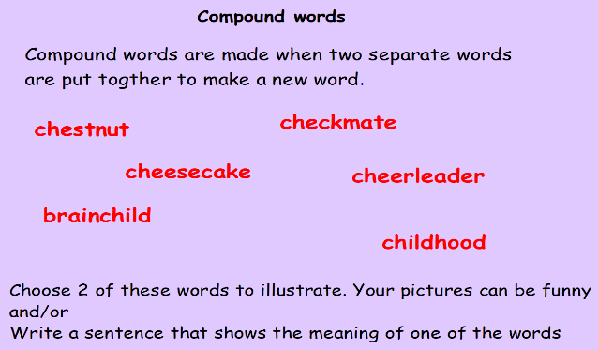 | Please read the pages of your bug club book.
Numeracy and Mathematics

Area and Perimeter


https://toytheater.com/perimeter-climber/

