Primary 6 Homework Overview 22/04/24
We are going digital! Please access this homework sheet on the school blog. https://blogs.glowscotland.org.uk/ea/mrsmitchell/homework/
If there are any issues accessing the blog, your teacher will issue a homework sheet. This is to reduce waste and costs. Thanks.
Spelling | Reading
Spelling: ‘j’  Copy your spelling words three times in your jotter, then complete the connectives activity.  Red Yellow Green  ship dish fish she chef ocean ancient Russia mansion chute machine lotion emotion shampoo shock anxious luxury surely conscious vicious magician discussion dimension brochure pollution  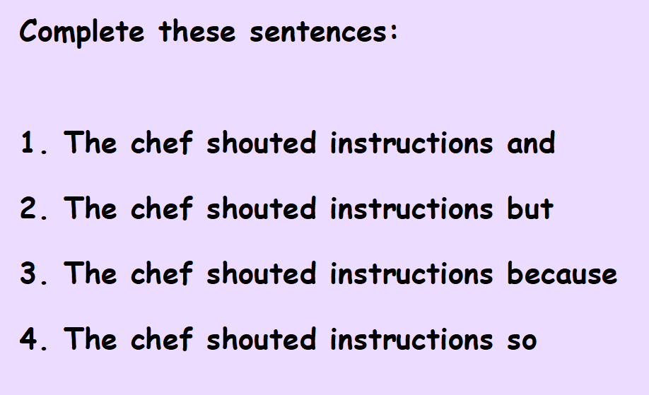 | Please read the pages of your bug club book allocated by your teacher.
Numeracy and Mathematics

Area and Perimeeter

https://firstlook.educationcity.com/content/Activity/index/25843

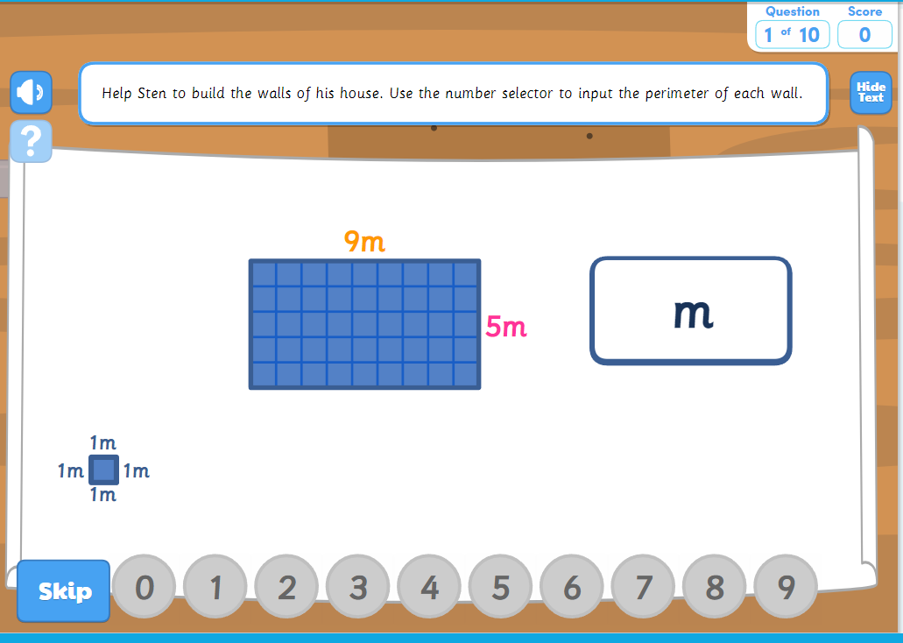
Red | Yellow | Green
ship  dish  fish  she  chef | ocean  ancient  Russia  mansion  chute  machine  lotion  emotion  shampoo  shock | anxious  luxury  surely  conscious  vicious  magician  discussion  dimension  brochure  pollution
k

