Primary 6 Homework Overview 29/04/24
We are going digital! Please access this homework sheet on the school blog. https://blogs.glowscotland.org.uk/ea/mrsmitchell/homework/
If there are any issues accessing the blog, your teacher will issue a homework sheet. This is to reduce waste and costs. Thanks.
Spelling | Reading
Spelling: ‘s’  Copy your spelling words three times in your jotter, then give Wordle a try! Find someone in your house to play with and you can either choose a word from the Wordle List of your own spelling word. Record this in your jotter.  Red Yellow Green  said so see bossy city yesterday across centre increase scent listen answer choice course Saturday satisfied successful exercise universe practice fascinate moisten sword psychic Switzerland  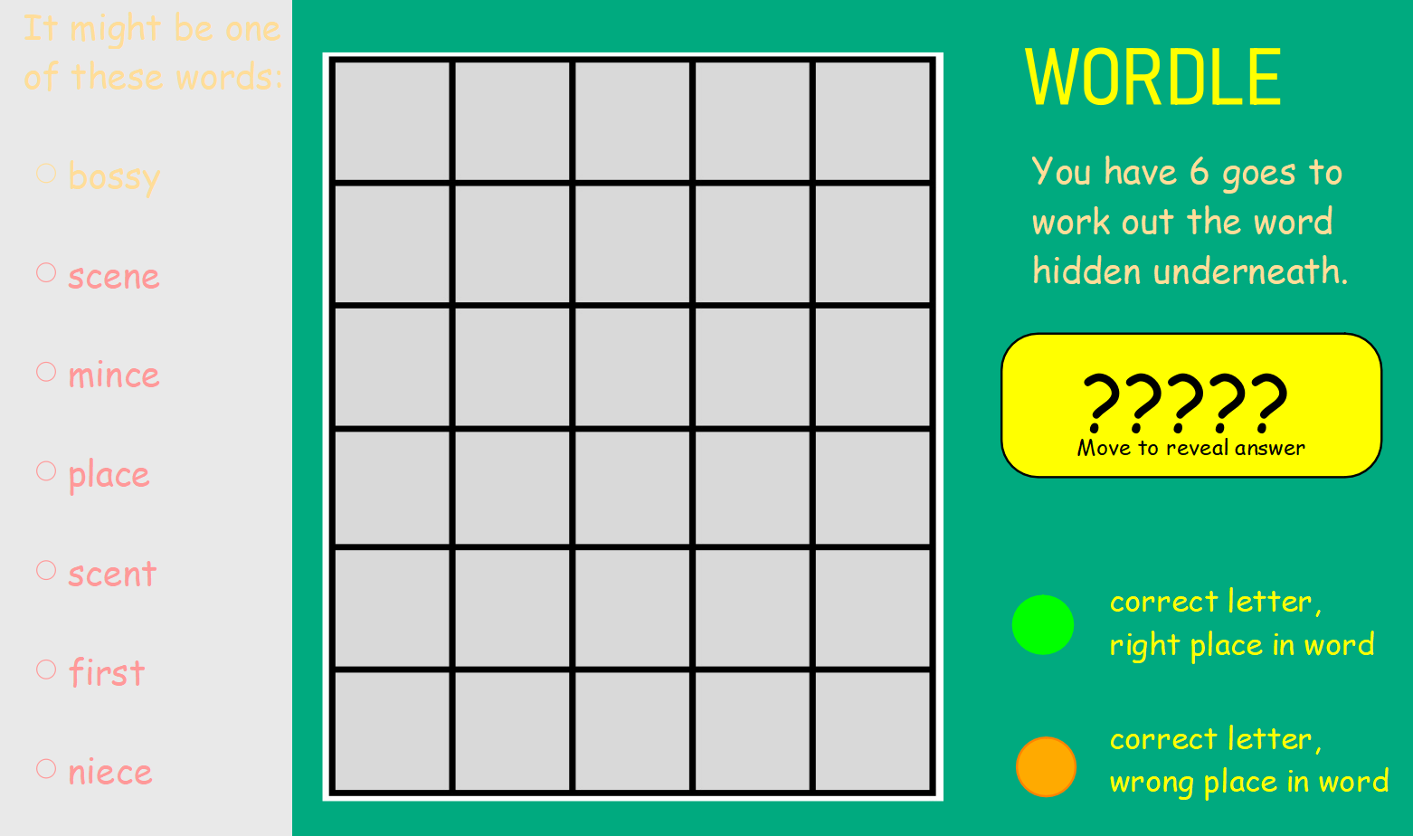 | Please read the pages of your bug club book allocated by your teacher.
Numeracy and Mathematics

Area and Perimeeter
https://toytheater.com/perimeter-climber/
