Primary 6 Homework Overview 22/04/24
We are going digital! Please access this homework sheet on the school blog. https://blogs.glowscotland.org.uk/ea/mrsmitchell/homework/
If there are any issues accessing the blog, your teacher will issue a homework sheet. This is to reduce waste and costs. Thanks.
Spelling | Reading
Spelling: ‘j’  Copy your spelling words three times in your jotter, then complete the connectives activity.  Red Yellow Green  ship dish fish she chef ocean ancient Russia mansion chute machine lotion emotion shampoo shock anxious luxury surely conscious vicious magician discussion dimension brochure pollution  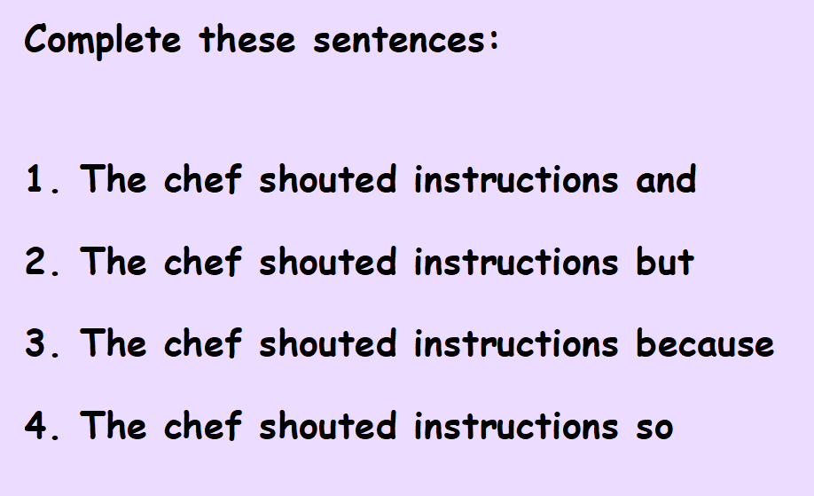 | Please read the pages of your bug club book allocated by your teacher.
Numeracy and Mathematics

Area and Perimeeter
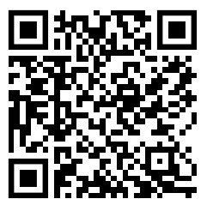
https://firstlook.educationcity.com/content/Activity/index/25843

