Primary 6 Homework Overview 15/04/24
We are going digital! Please access this homework sheet on the school blog. https://blogs.glowscotland.org.uk/ea/mrsmitchell/homework/
If there are any issues accessing the blog, your teacher will issue a homework sheet. This is to reduce waste and costs. Thanks.
Spelling | Reading
Spelling: ‘j’  Copy your spelling words three times in your jotter, then complete the homophone activity.  Red Yellow Green  jump just magic cage edge January journey engine tragedy sledge dodgy change fringe education duty suggest exaggerate adjective soldier gradually dungeon grudge courageous marriage jealous  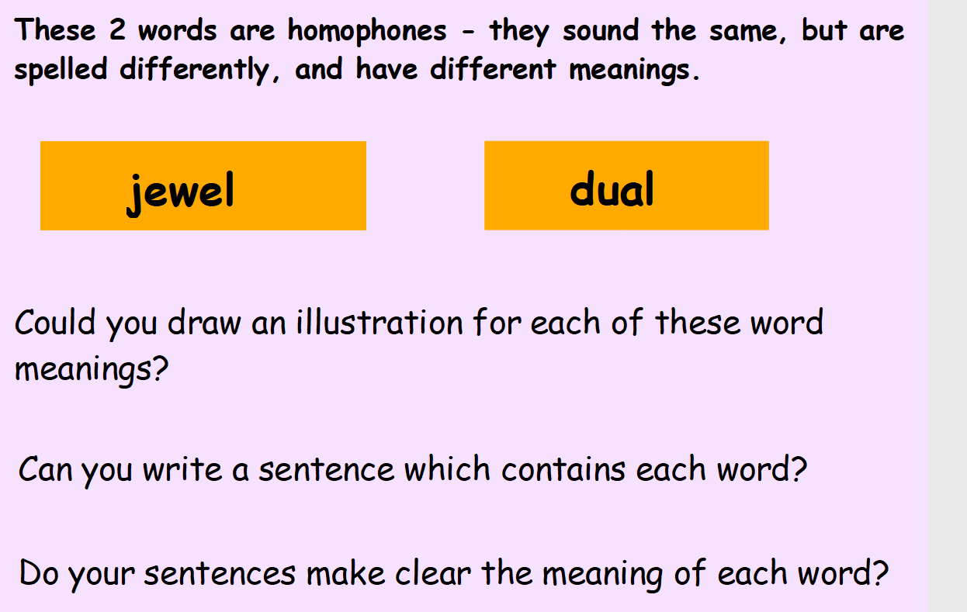 | Please read the pages of your bug club book allocated by your teacher.
Numeracy and Mathematics

Multiplication Tetris

https://www.coolmathgames.com/0-number-drop
