Primary 6 Homework Overview 18/03/24
We are going digital! Please access this homework sheet on the school blog. https://blogs.glowscotland.org.uk/ea/mrsmitchell/homework/
If there are any issues accessing the blog, your teacher will issue a homework sheet. This is to reduce waste and costs. Thanks.
Spelling | Reading
Spelling: ‘kw’  Copy your spelling words three times in your jotter, then complete the spelling activities!  Red Yellow Green  quick quiz quit quack quest squirrel quite quiet quit equipment request question equal squeeze earthquake squawk conquest quantity quality equality frequently require exquisite subsequently consequently  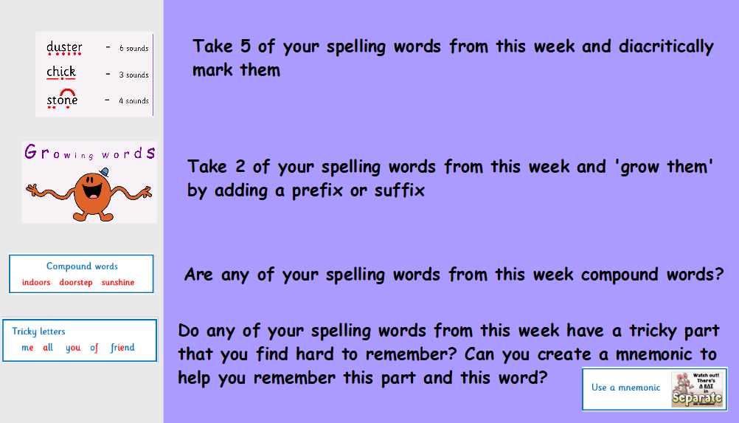 | Please read the pages of your bug club book allocated by your teacher.  Draw a picture of something or someone interesting from your book!
Numeracy and Mathematics

Multiplication Tetris

https://www.coolmathgames.com/0-number-drop
