Primary 6 Homework Overview 11/03/24
We are going digital! Please access this homework sheet on the school blog. https://blogs.glowscotland.org.uk/ea/mrsmitchell/homework/
If there are any issues accessing the blog, your teacher will issue a homework sheet. This is to reduce waste and costs. Thanks.
Spelling | Reading
Spelling: ‘k’  Copy your spelling words three times in your jotter, then diacritically mark (record the number of sounds, not letter, in each word).  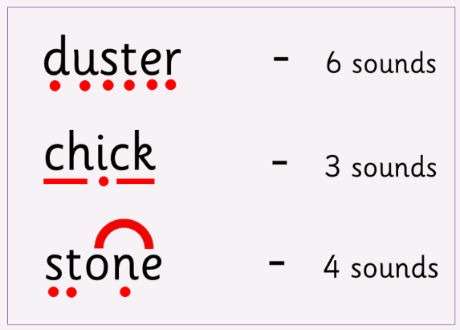  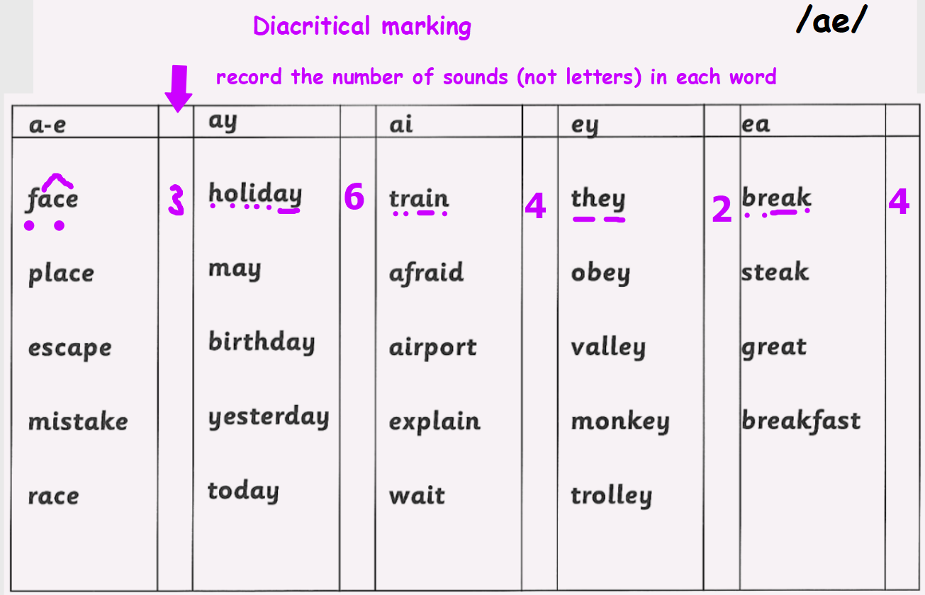  Red Yellow Green  text winks books ducks bikes texture blinks rucksack mistakes success successful successfully examine explain accept explanation bookseller backstage vaccine vaccination successful successfully accelerate acceleration exaggerate | Please read the pages of your bug club book allocated by your teacher.
Numeracy and Mathematics
Multiplication Snakes: Choose your times table and level of challenge!

https://www.mathplayground.com/multiplication_snake.html
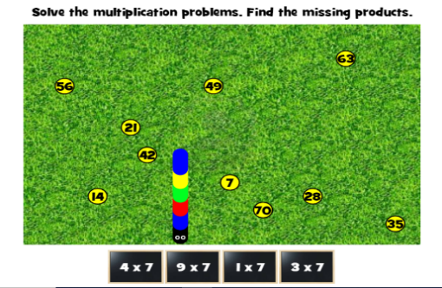
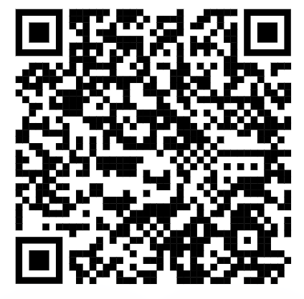

Converting Length: ‘mm to cm’
https://kids.classroomsecrets.co.uk/resource/year-3-equivalent-lengths-mm-and-cm-game/

