Primary 6 Homework Overview 04/03/24
We are going digital! Please access this homework sheet on the school blog. https://blogs.glowscotland.org.uk/ea/mrsmitchell/homework/
If there are any issues accessing the blog, your teacher will issue a homework sheet. This is to reduce waste and costs. Thanks.
Spelling | Reading
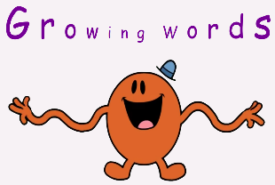  Spelling: ‘k’  Copy your spelling words three times in your jotter, then complete this week’s spelling activity;  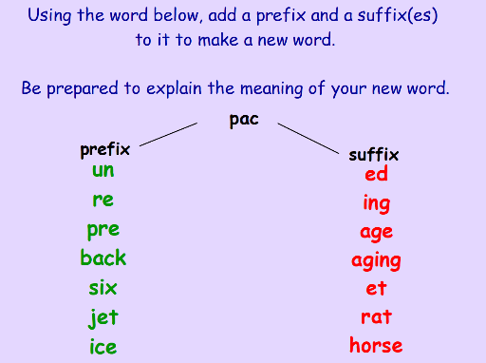  Red Yellow Green  can keep back school soccer Cumnock wake tickle stomach account mosquito cheque Kilmarnock because Scotland cousin practice practise skilful shipwreck character accommodate queue unique khaki | Please read the pages of your bug club book allocated by your teacher.  From your reading book can you find your least favourite character and explain why you don’t like them?
Numeracy and Mathematics
Multiplication Snakes: Choose your times table and level of challenge!

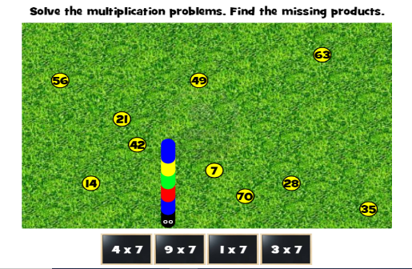
https://www.mathplayground.com/multiplication_snake.html

Converting Length: ‘mm to cm’
https://kids.classroomsecrets.co.uk/resource/year-3-equivalent-lengths-mm-and-cm-game/
