Primary 6 Homework Overview 19/02/24

We are going digital! Please access this homework sheet on the school blog. https://blogs.glowscotland.org.uk/ea/mrsmitchell/homework/
If there are any issues accessing the blog, your teacher will issue a homework sheet. This is to reduce waste and costs. Thanks.
Spelling | Reading
Spelling: ‘ow’  Copy your spelling words three times in your jotter, then you choose one of the following activities…  Create a sentence with 2 or 3 of your words and then draw a picture to illustrate the sentence.  or  Put your words into alphabetical order.  or  Choose your favourite word from the week to illustrate  in some way.  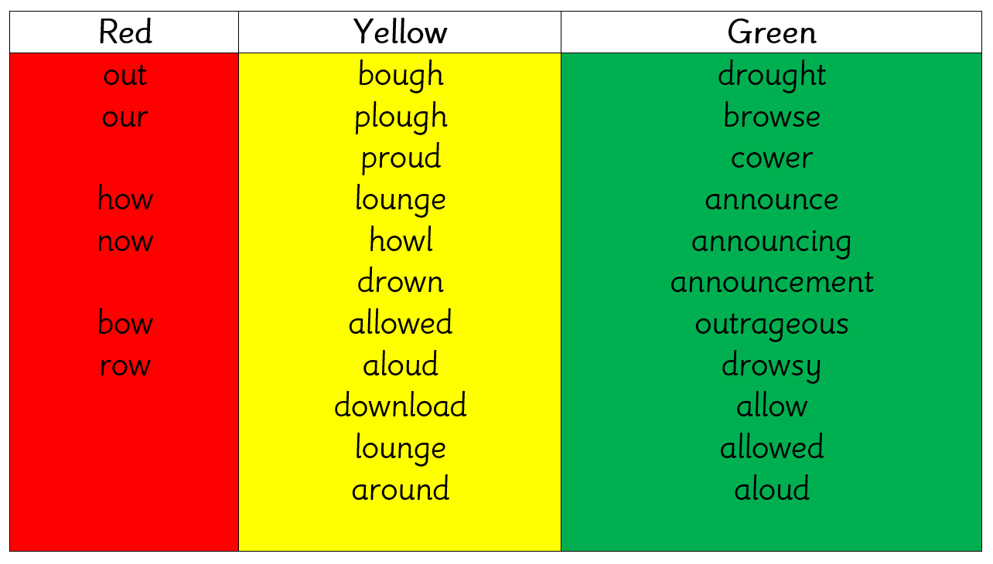 | Please read the pages of your bug club book allocated by your teacher.
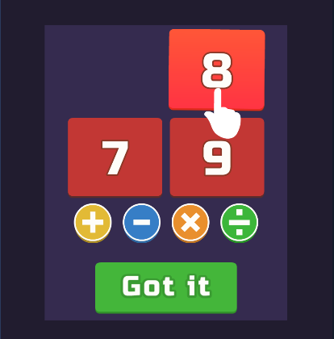
Numeracy and Mathematics
Try ‘Number Solver’ on Coolmath Games. Scan the QR code or follow the link on the homework sheet (access from school blog).

https://www.coolmathgames.com/0-number-solver?variant=sdv2

