Primary 6 Homework Overview 05/02/24

We are going digital! Please access this homework sheet on the school blog.
If there are any issues accessing the blog, your teacher will issue a homework sheet. This is to reduce waste and costs. Thanks.
Spelling | Reading
Spelling: ‘g’  Copy your spelling words three times in your jotter, then complete the word maker activity. Using the different representations of the phoneme ‘g’, how many words can you build, using the letters in the phoneme maker grid?  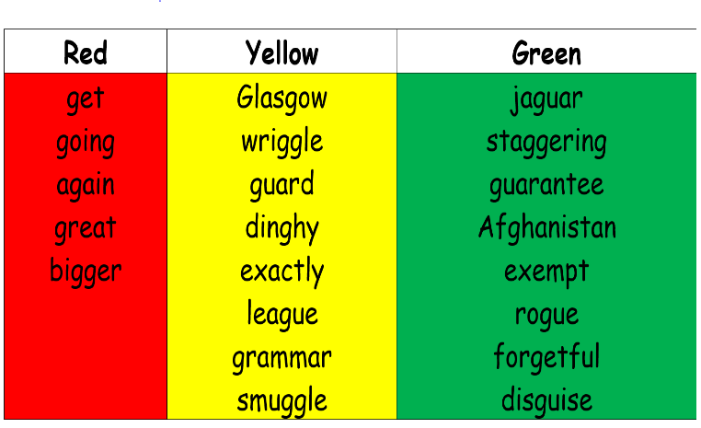  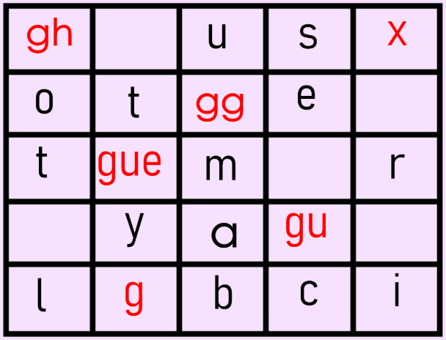  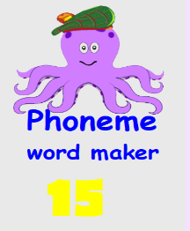 | In your reading book can you find 5 words or more that you don’t know the meaning of? Try to work out what they mean.  Please read the pages of your bug club book allocated by your teacher.
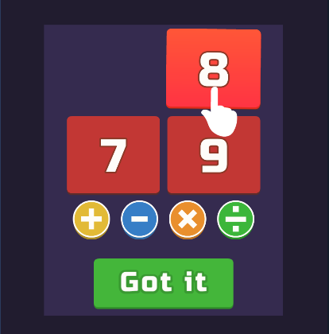
Numeracy and Mathematics
Try ‘Number Solver’ on Coolmath Games. Scan the QR code or follow the link on the homework sheet (access from school blog).

https://www.coolmathgames.com/0-number-solver?variant=sdv2

