Primary 6 Homework Overview 26/1/24
Burns | Spelling/Reading
Well done if you have managed to recite your whole poem. Keep practising if you are not there yet. Remember, if you don’t want to be part of the Burns competition, that’s okay, but we would really like to hear you present, to assess your solo presentation.  Song Competition  Mr Maddocks is looking for a group/soloist who would like to sing ‘Green Grow’. Please practise this song and let me know if you would like to be considered. To access this link, you will need to access this homework sheet from the Primary 6 homework tab.  https://www.youtube.com/watch?v=Io-n-WIcj_M | Reading Homework:Continue to read your book at home.  RED YELLOW GREEN  for from off bluff staff February friendly following effort muffin offer sphere paragraph Joseph elephant satisfied performance fierce offensive affect atmosphere pharmacy triumph physical alphabet  Spelling: Copy your spelling words three times in your jotter, then complete the metalinguistic activity.  f,ff,ph  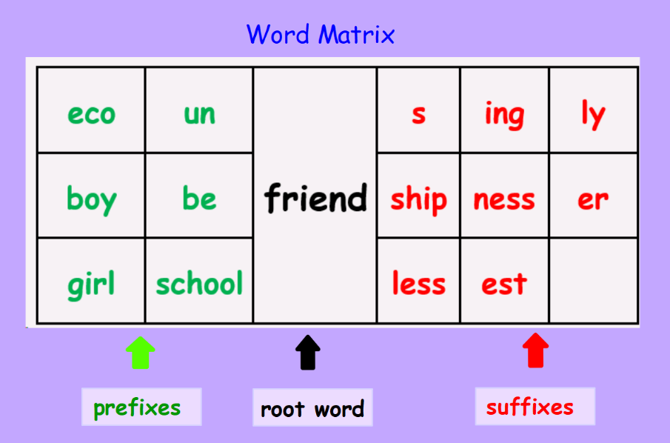  We can add a prefix or suffix, before or after a word, to create new words. Have a go, using the word Matrix below. How many words can you make? Can you create any new words using a prefix AND a suffix? Words have to make sense, so make sure you can explain the word!

RED | YELLOW | GREEN
for  from  off  bluff  staff | February  friendly  following  effort  muffin  offer  sphere  paragraph  Joseph  elephant | satisfied  performance  fierce  offensive  affect  atmosphere  pharmacy  triumph  physical  alphabet

