Primary 6 Homework Overview 15/1/24
Burns | Spelling/Reading
Mrs Mitchell and I have been so impressed that you have all been working so hard on your poem. It has been great to see your confidence grow when reciting in the class.  Please learn the whole poem “To a Mouse”. This will be judged next Monday afternoon.  We will use your performance to assess listening and talking this term. We know that not everyone feels confident presenting at the Burns Supper. Please don’t worry. We can do this in class.  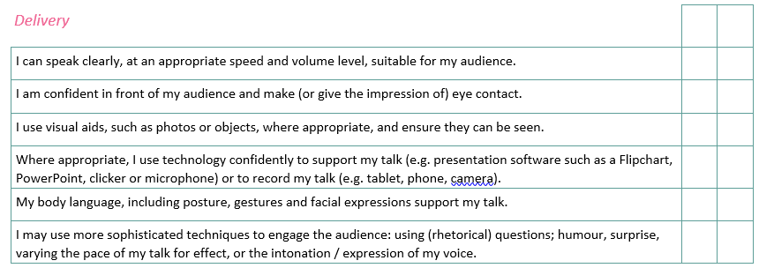  s  Song Competition  Remember, if you want to take part in the Burns singing competition, please practise the songs. They are in the homework tab of the Drongan P.S. blog. Good Luck! | 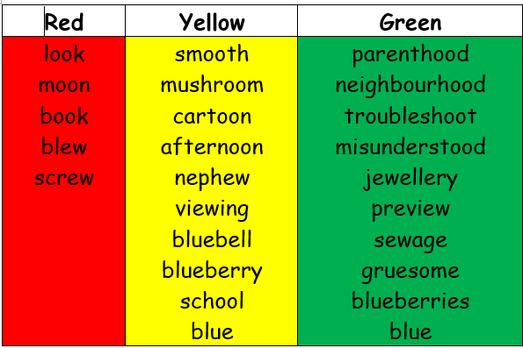  Reading Homework  Continue to read your book at home.  Spelling  Copy your spelling words three  times in your jotter.  TASK  Phoneme Word Maker  Create words using the letters given.  Use the blank squares to add new letters to help make more words.  