Primary 6 Homework Overview 15/1/24
Burns | Reading
Please practise the first two verses of your Burns Poem, “To a Mouse”. If you are feeling confident, try the next two!  We will use your performance to assess listening and talking this term. We know that not everyone feels confident presenting at the Burns Supper. Please don’t worry. We can do this in class.  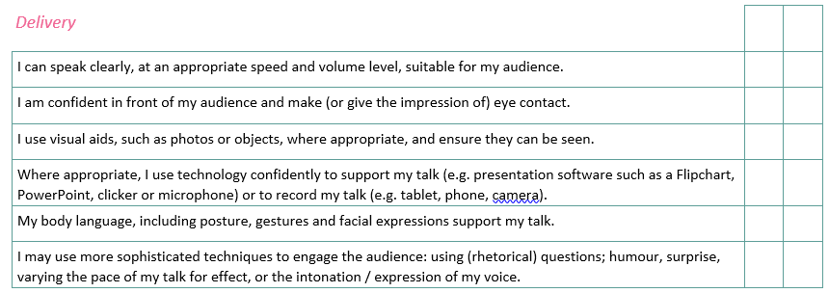  s  We will also choose two class winners to represent the class at the Burns Supper.  Good Luck!!!  A copy of the poem is attached to your homework.  The Immortal Memory  Complete The Immortal Memory writing challenge at home. Pleae return by next Monday. You can do more research and ask family members to help you. | Reading Homework  Which character from your book do you like most? Why is this character your favourite?  Bug Club  Please read the pages of your book allocated by your teacher

To a Mouse

Wee, sleekit, cow'rin, tim'rous beastie,
O, what a panic's in thy breastie!
Thou need na start awa sae hasty,
Wi' bickering brattle!
I wad be laith to rin an' chase thee,
Wi' murd'ring pattle!

I'm truly sorry man's dominion,
Has broken nature's social union,
An' justifies that ill opinion,
Which makes thee startle
At me, thy poor, earth-born companion,
An' fellow-mortal!

I doubt na, whiles, but thou may thieve;
What then? poor beastie, thou maun live!
A daimen icker in a thrave
'S a sma' request;
I'll get a blessin wi' the lave,
An' never miss't!

Thy wee bit housie, too, in ruin!
It's silly wa's the win's are strewin!
An' naething, now, to big a new ane,
O' foggage green!
An' bleak December's winds ensuin,
Baith snell an' keen!

Thou saw the fields laid bare an' waste,
An' weary winter comin fast,
An' cozie here, beneath the blast,
Thou thought to dwell -
Till crash! the cruel coulter past
Out thro' thy cell.

That wee bit heap o' leaves an' stibble,
Has cost thee mony a weary nibble!
Now thou's turn'd out, for a' thy trouble,
But house or hald,
To thole the winter's sleety dribble,
An' cranreuch cauld!

But, Mousie, thou art no thy lane,
In proving foresight may be vain;
The best-laid schemes o' mice an 'men
Gang aft agley,
An' lea'e us nought but grief an' pain,
For promis'd joy!

Still thou art blest, compar'd wi' me
The present only toucheth thee:
But, Och! I backward cast my e'e.
On prospects drear!
An' forward, tho' I canna see,
I guess an' fear!

