Primary 6 Homework Overview 04/12/23
Spelling | Reading | Numeracy and Mathematics
Spelling Homework Jotter  This week your spelling words are based on ‘adjectives’ that will improve your descriptive writing.  Use the list you have chosen, from the table below, to complete this week’s spelling tasks.  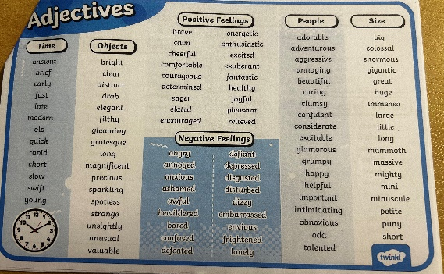  Spelling Task  - Copy each word 3 times in your spelling jotter, using your spelling strategies to help remember each word.  - Write a paragraph, using at least 5 of your spelling adjectives. This can be about your weekend, a special event or something you enjoyed. | Reading Homework  Book report  When reading your Bug club book at home create a short book report. Talk about the characters, the best bit of the book and write a short summary.  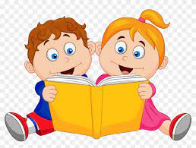  Please read the pages of your bug club book allocated by your teacher  Bug Club  Please read the pages of your book allocated by your teacher  Have fun! | Using the QR codes below, play the games below!  Following Directions  Try the following game and self-assess your knowledge of 8 compass points…  https://wordwall.net/resource/399676/maths/compass-8-points  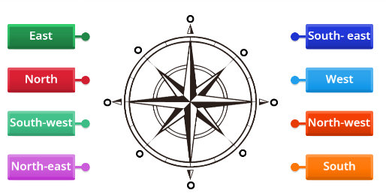  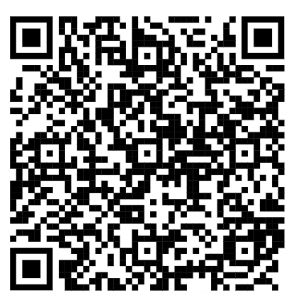  Multipication Masters  Focus on one multiplication table at a time – Practise and let’s see who can achieve their multiplication master certificate this week!  https://www.timestables.co.uk/  