Primary 6 Homework Overview 27/11/23
Spelling | Reading | Numeracy and Mathematics
Spelling Homework Jotter  This week your spelling words are ‘connectives’. Connectives are used to join two sentences together, instead of ending the sentence. This can be useful when linking ideas or giving extra information about the first sentence.  Learning these words will improve your story writing, helping you to achieve the next level!  Spelling Task  - Copy each word 3 times in your spelling jotter, using your spelling strategies to help remember each word.  - Write a paragraph, using at least 5 of your spelling word to connect two sentences together. This can be about your weekend, a special event or something you enjoyed.  Red Yellow Green  and but then so because however despite although unlike after before while unless yet because however despite although unlike after except nevertheless throughout including otherwise | Reading Homework  We know how important the illustrator is as well as the author.  Be an illustrator! You are the illustrator! Draw a picture that would fit into your book and write about it.  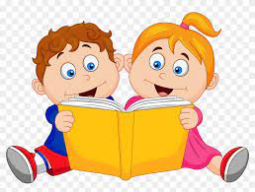  Please read the pages of your bug club book allocated by your teacher  Bug Club  Please read the pages of your book allocated by your teacher  Have fun! | Using the QR codes below, play the games to develop your skills in adding and multiplication!  Following Directions  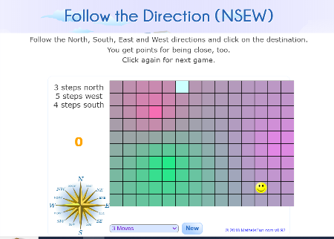  https://www.mathsisfun.com/games/direction-nsew-.html  Mental Maths  Choose a mixture of calculations to sharper up you mental maths skills and Beat That scores!  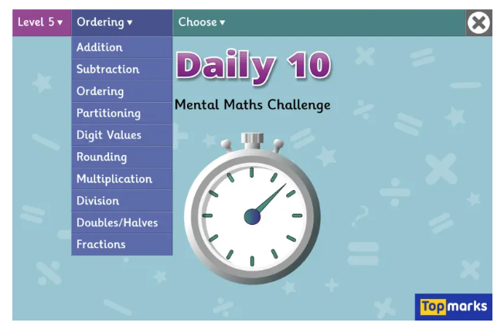  https://www.topmarks.co.uk/maths-games/daily10

