Primary 6 Homework Overview 20/11/23
Spelling | Reading | Numeracy and Mathematics
Spelling Homework Jotter  This week your spelling words are ‘time connectives and sentence openers’. Learning these words will improve your story writing, helping you to achieve the next level!  On Monday, we researched what the word meant and how it is used in a sentence.  Spelling Task  - Copy each word 3 times in your spelling jotter, using your spelling strategies to help remember each word.  - Write a paragraph, using at least 5 of your spelling word to open each sentence. This can be about your weekend, a special event or something you enjoyed.  Red Yellow Green  then next later finally soon then next later eventually meanwhile immediately afterwards finally yesterday suddenly subsequently notably consequently initially alternatively similarly likewise whereas meanwhile eventually | Reading Homework  Using the name of the author of your book complete the challenge below  Author Challenge  Write the name of the author of your book in your jotter.  Using only the letters in the author’s name, see how many words you can make.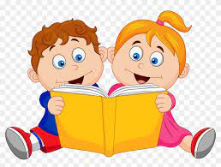  Please read the pages of your bug club book allocated by your teacher  Bug Club  Please read the pages of your book allocated by your teacher  Have fun! | Using the QR codes below, play the games to develop your skills in adding and multiplication!  Following Directions  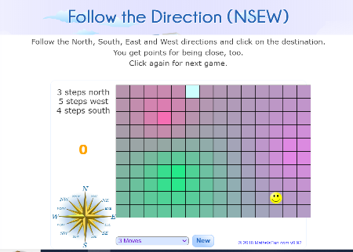  https://www.mathsisfun.com/games/direction-nsew-.html  Mental Maths  Choose a mixture of calculations to sharper up you mental maths skills and Beat That scores!  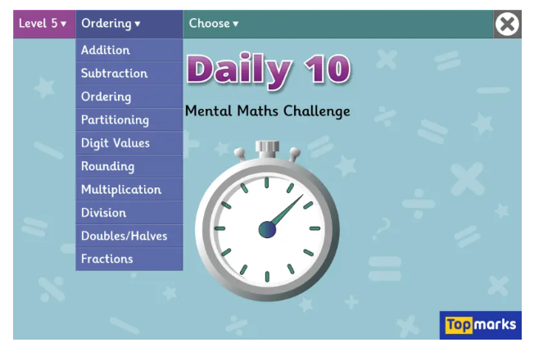  https://www.topmarks.co.uk/maths-games/daily10

