Primary 6 Homework Overview 13/11/23
Spelling | Reading | Numeracy and Mathematics
Spelling Homework Jotter  This week we have explored tricky and topic words.  Copy each word 3 times in your spelling jotter, using your spelling strategies to help remember each word. Have a look at the spelling strategies below!  Red Yellow Green  pie lie die tie tied cries cried fries magpie tries supplies supplied applies occupies replies defies denied justifies clarifies terrifies allies allied horrifies implies  Spelling Task  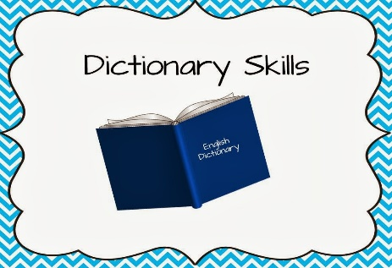  Use a dictionary or an online dictionary to find the meaning of 4 of your spelling words above! | Reading Homework  Inference Challenge Card  Answer the 5 inferential questions below in your jotter!  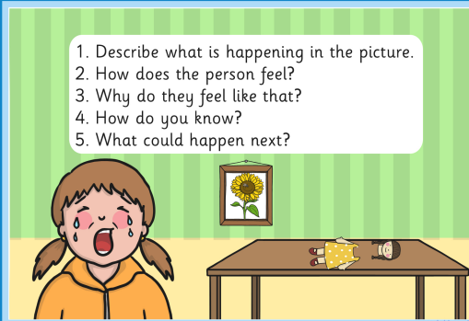  Bug Club  Please read the pages of your book allocated by your teacher | Using the QR codes below, play the games to develop your skills in adding and multiplication!  Check out Transum Maths to develop your knowledge and skill of number and number processes!  Hit the Button  LI- To be able to develop my multiplication skills

