Primary 6 Homework Overview 06/11/23
Spelling | Reading | Numeracy and Mathematics
Spelling Homework Jotter  This week we have explored tricky and topic words.  Copy each word 3 times in your spelling jotter, using your spelling strategies to help remember each word. Have a look at the spelling strategies below!  Red Yellow Green  get let went then them when were any very well expect engage against anyone friend wealth breakfast measure fresh successful jeopardy leopard buried leisure anywhere against extinct stealthy successful breadth  Spelling Task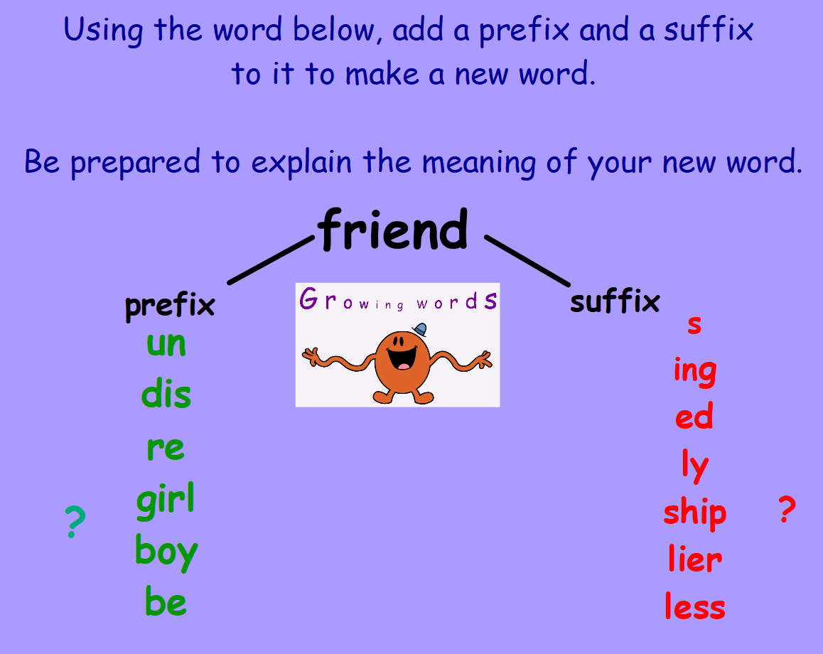 | Reading Homework  Design an award for one of the main characters based on their actions in your book. Then say why they deserve the award.  Bug Club  Please read the pages of your book allocated by your teacher | Using the QR codes below, play the games to develop your skills in adding and multiplication!  Check out Transum Maths to develop your knowledge and skill of number and number processes!  Hit the Button  LI- To be able to develop my multiplication skills

