Primary 6 Homework Overview 04/09/23
Spelling | Reading | Numeracy and Mathematics
Spelling Homework Jotter  This week we have explored different ways the sounds ‘ai’ can be represented.  Copy each word 3 times in your spelling jotter, using your spelling strategies to help remember each word. Have a look at the spelling strategies below!  Spelling Task:  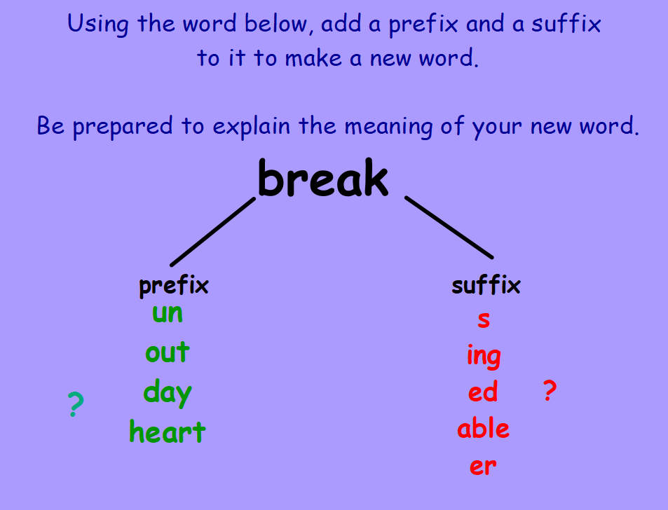  Record the activity below in your spelling jotter.  Challenge: Can you add a prefix or suffix to any of your spelling words? Record in your results. | Reading Homework  This week we have been exploring the reading strategy visualisation.  Can you use the poem in the table below to create a visual image?  SUNBURN  Ouch be careful!  please don’t touch,  as sunshine burns,  if you get too much.  My skin feels so hot,  and my face is an awful bright red,  cover me in a soothing cream,  and send me off to bed! | Using the QR codes below, play the games to develop your skills in adding and multiplication!  Adding Darts  LI- To be able to develop accuracy in adding digits  Hit the Button  LI- To be able to develop my multiplication skills

Spelling List (4th September 2023)
aim  rain  train  paint  paid | their  eight  where  table  April  breakfast  valley  they  crayon  today | straighten  aeroplane  beige  reign  dangerous  angel  breakable  greatness  disobey  Ayrshire
