Make a Disney Board Game for the summer

This task could be completed with another person. Perhaps an older or younger brother or sister would like to do it too.
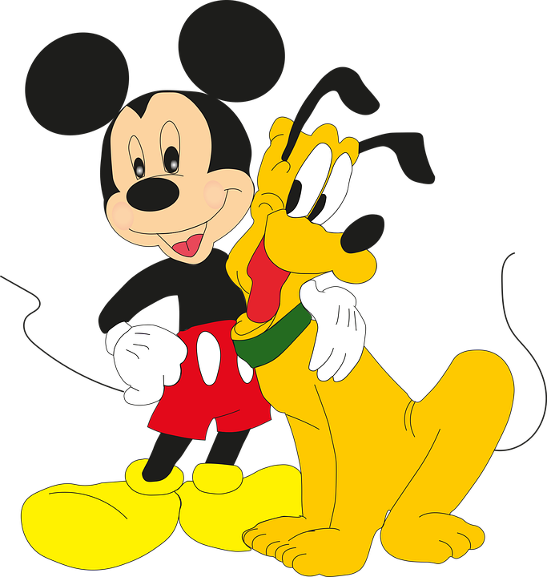 Questions to help | Make a Disney Board Game  Notes (yours) or Hints (Mine) | 
1* Decide on your theme. Will it be for a single film or from all of them. | Film / variety of characters | Tick
2* Will it be a track like monopoly or a 100 square like snakes and ladders, or something else? | I have loaded some templates for board games you can use IF YOU WISH.  https://www.tes.com/teaching-resource/blank-board-game-templates-11195571
3* How will you move back, will it be cards or down a slide, or something else?
4* How many players? (How many pieces to move around?) | You could use toys you have or you could draw them on paper and stick them on to card. Or you could print some out from the internet and stick them down on card.
5* Will you make it with cardboard to keep and use all summer? Or will you use chalk and do it on the ground outside?
6* What equipment will you need? | An empty cereal box cut open will give you your cardboard. Scissors, glue, colouring pens/ pencils, paper, Cards for tasks?
7* Rules (write them out so that there are no arguments later.)
8* Test. Play the game to see if the rules work. Go back and edit, rewrite or add in new rules.
9* This is not a mistake. You may have to do this many times. Test. Play the game to see if the rules work. Go back and edit, rewrite or add in new rules.
10* Ask everyone in your household to play your game with you. | They may have some suggestions too. It's your game, you can decide when it's ready.

