Tuesday 16th & Wednesday 17th June

Today is going to be about collaboration. If you have a sister or a brother, perhaps they will enjoy doing this with you.

Task 1

Have a look at this list of rides for Disney World Florida’s Magic Kingdom. Unfortunately you don't have time to visit them all. You and your family can only go to ten of them. The same ten! That means you must discuss and agree with at least one other person, which ten.

down

Scroll down

down

Nearly there

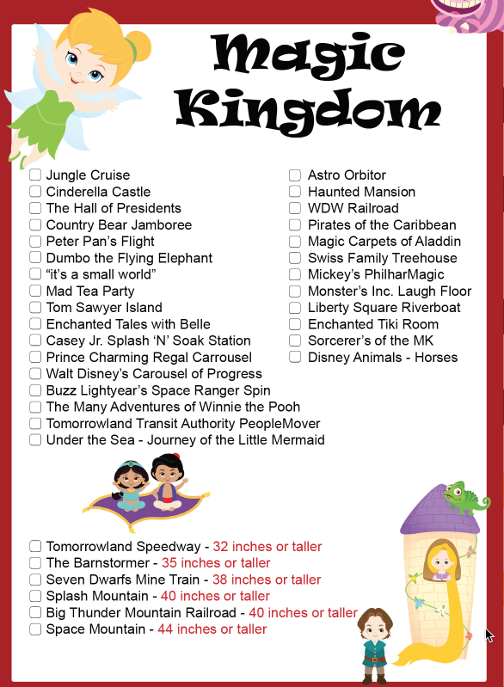

Task 2

Today you are going to build your own Disney Ride. That’s it! That’s today's lesson!

Check list.

|  |  |
| --- | --- |
| To do | tick |
| Decide on a Disney theme, e.g, Frozen or the Incredibles. |  |
| Think about ways you can make your model show your theme. (Maybe you have someone in the house who likes to dress up in a Disney costume and could become the character?) |  |
| Who will use your ride? You? An action figure or doll? |  |
| Where are you going to build your ride? Inside with the furniture? Outside with what’s in your garden? Junk model? Construction toys, e.g Lego or Skelectrix. |  |
| What kind of ride is it going to be? Will it be a roller coaster or Big Wheel or a ride through attractions? Will there be water? |  |
| How big or small will it be? |  |
| Sketch out your plan in pencil so that you can rub out. |  |
| Do a separate sketch for your car. |  |
| Make a list of the materials you will need and do you have them? |  |
| Alter your plan to suit what you have. |  |
| Build your ride. |  |
| Use your ride. Photograph it and send it to me. |  |

Success criteria: can you, someone else or your toy get around your ride without it breaking or missing bits out.