|  |  |  |  |  |  |  |  |  |  |
| --- | --- | --- | --- | --- | --- | --- | --- | --- | --- |
|  |  |  |  |  |  |  |  |  |  |
|  |  |  |  |  |  |  |  |  |  |



Names: __________________________________________________________________

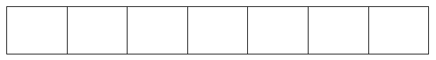

A phoneme is a speech sound. - single phonemes: ‘a’, ‘d’

- joined phonemes: ‘sh’ ‘igh’ - split phonemes: ‘note’ ‘game’

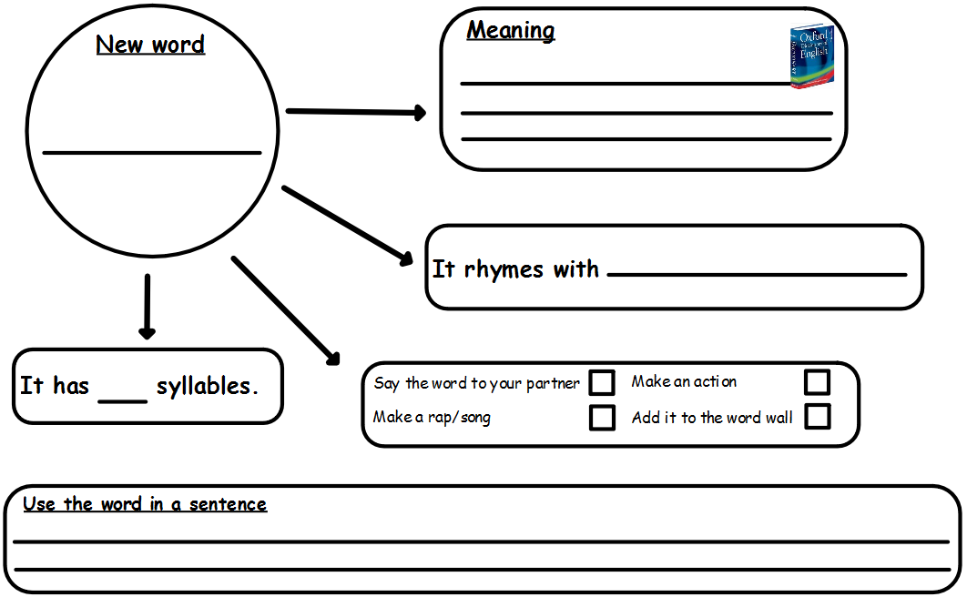

**Draw a picture/symbol**

**Use the word in a sentence ________________________________________________________________________________________________________________________________________________________________________________________________________**