[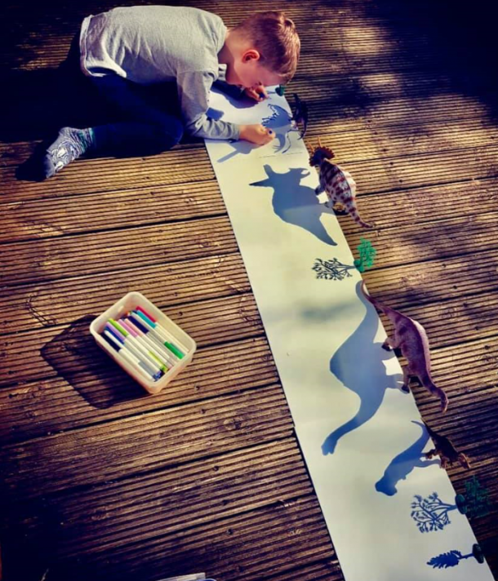](https://www.google.com/url?sa=i&url=https%3A%2F%2Fkidsactivitiesblog.com%2F137133%2Fhow-to-make-shadow-art-with-kids%2F&psig=AOvVaw1aP--k70pEhVhvpSxRwO5f&ust=1587467652522000&source=images&cd=vfe&ved=0CAIQjRxqFwoTCPC_9ezv9ugCFQAAAAAdAAAAABAE)

[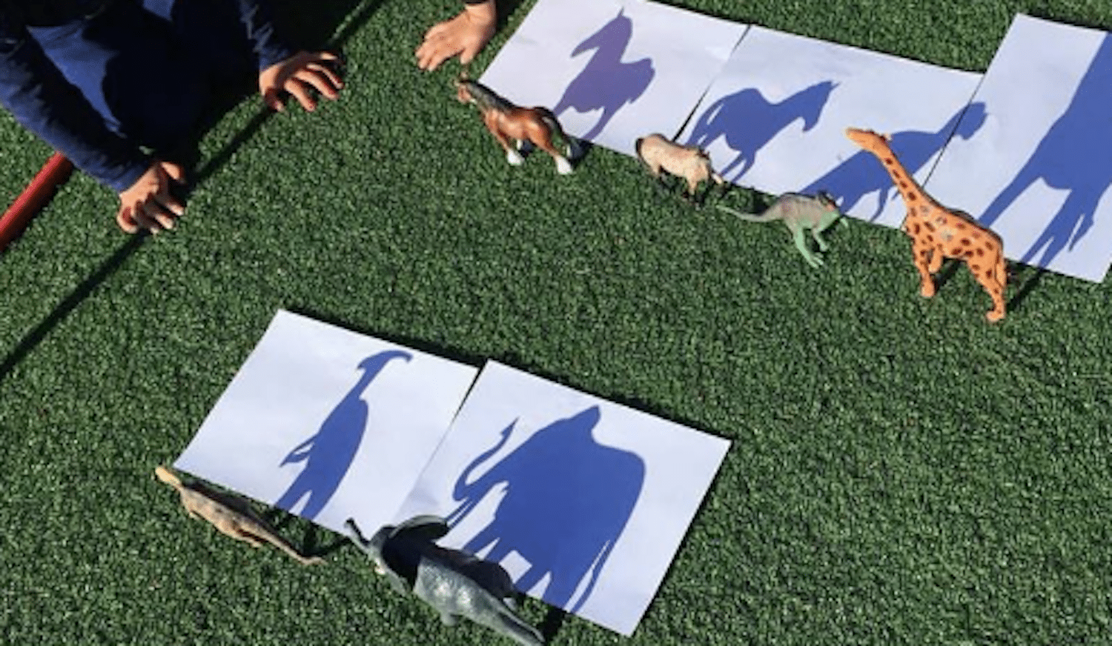](https://www.google.com/url?sa=i&url=https%3A%2F%2Fwww.simplemost.com%2Fthis-shadow-drawing-project-is-perfect-for-entertaining-your-kids-this-summer%2F&psig=AOvVaw1aP--k70pEhVhvpSxRwO5f&ust=1587467652522000&source=images&cd=vfe&ved=0CAIQjRxqFwoTCPC_9ezv9ugCFQAAAAAdAAAAABAJ)