[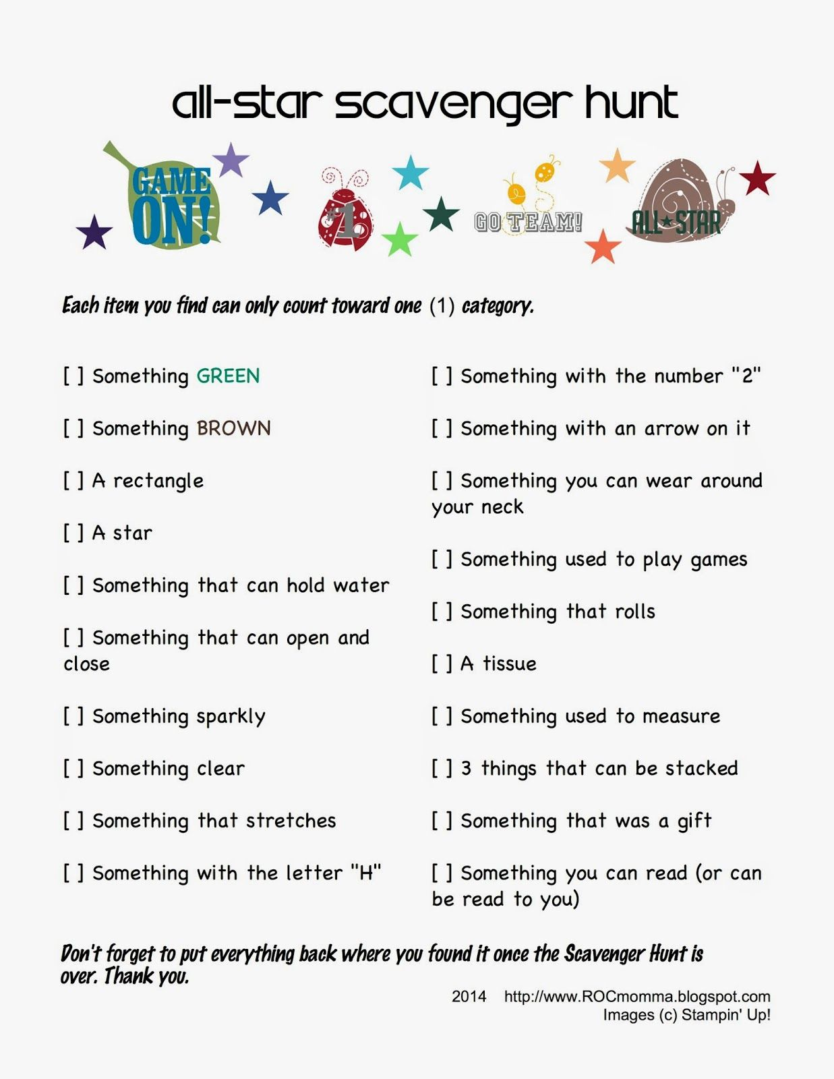](https://www.google.com/url?sa=i&url=https%3A%2F%2Fwww.pinterest.com%2Fpin%2F254101603952278128%2F&psig=AOvVaw3ovQyr7Th5hnHSxzcyqtD7&ust=1587467265085000&source=images&cd=vfe&ved=0CAIQjRxqFwoTCKD-krTu9ugCFQAAAAAdAAAAABAN)