P5 Homework Activities
Week Beginning: 26/10/26
Monday – Thursday
Try to work on some homework tasks each night. You can fit them in around your family schedule. Return your jotters to school on a Friday please.

SPELLING : Phoneme
Spelling Test in class for this week’s spelling words.

Group 1 | Group 2 | Group 3
Common/Tricky Words | Common/Tricky Words | Common/Tricky Words
surprise | some | her
care | never | before
busy | know | day
accident | yellow | away
below | father | always
cloudy | mother | today
eleven | each | each
football | year | ask
group | away | year
holiday | always | eat
I’m
I’ve

- Look at the spelling words for your group, copy each word 3 times.
- Choose any 5 of words from your list, write 5 sentences using at least a capital letter, full stop. Challenge yourself to use doffernt punctuation- ?!”,’
- Try to include an adjective( decribing word) .
- If you want a challenge you can do all 10 or find the meanings of the words you don’t know!
EXTRA: Try some different activities from the grid below to help you too.
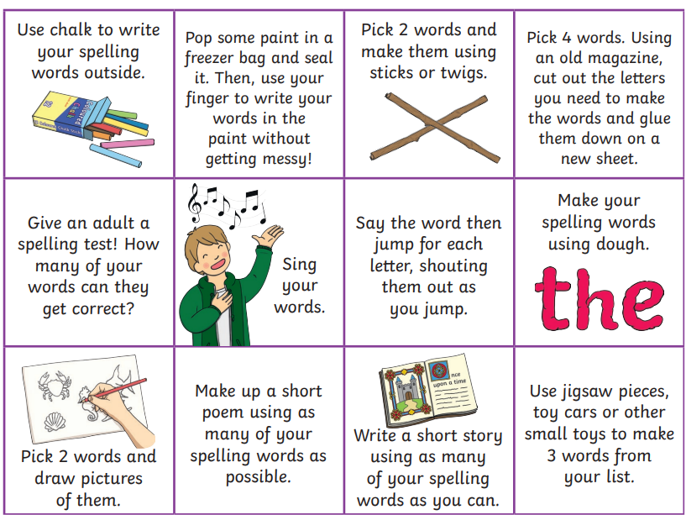

NUMERACY
Use the multiplication table and link to these websites to practice your times tables.
https://www.timestables.co.uk/
https://www.topmarks.co.uk/maths-games/hit-the-button
https://www.topmarks.co.uk/maths-games/daily10

Multiplication Task:
Can you create your own 5x or 10x table game which can be used in class during Multiplication Masters. This could be a board game, card game or any other type you can think of. What resources do you need to play the game. Be creative and make your game fun and exciting!
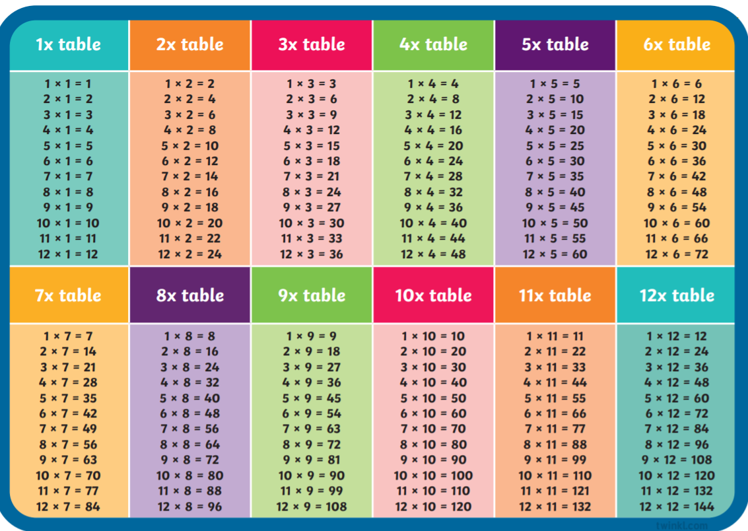
Money:
Convert the following amounts into pounds and pence. Remember to use a decimal point to separate pounds and pence. E.g. 1. 412p £4.12
Ex. 2. 3121p £31.21

- 319p 6. 2314p
- 198p 7. 7791p
- 721p 8. 40p
- 930p 9. 9098p
- 866p 10. 4002p

Toy Shop Money Game – Mixed Coins – Amounts £1 - £10.
Challenge yourself by finding as many ways as possible to make the exact amounts from the game. You can write these down in your jotter.
https://www.topmarks.co.uk/money/toy-shop-money

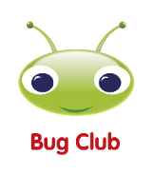
READING

A book has been sent home for reading practice. Try fitting this into your nightly routines where possible.

NESSY
Use your log in for NESSY to try out the activities.

