P5 Homework Activities
Week Beginning: 19/10/26
Monday – Thursday
Try to work on some homework tasks each night. You can fit them in around your family schedule. Return your jotters to school on a Friday please.

SPELLING : Common words
Spelling Test in class for this week’s spelling words.
Group 1 | Group 2 | Group 3
ng (ng, nk, ngue, -nd) | ou, igh, y | oo, ee
ring  string  thing  wrong  evening  blank  blink  prank  tongue  handkerchief | mouse  count  round  pounce  fright  light  high  spy  cry  why | pool  tool  moon  spoon  school  green  sheep  wheel  screen  greet

- Look at the spelling words for your group, copy each word 3 times.
- Choose any 5 of words from your list, write 5 sentences using at least a capital letter, full stop. Challenge yourself to use doffernt punctuation- ?!”,’
- Try to include an adjective( decribing word) .
- If you want a challenge you can do all 10 or find the meanings of the words you don’t know!
EXTRA: Try some different activities from the grid below to help you too.
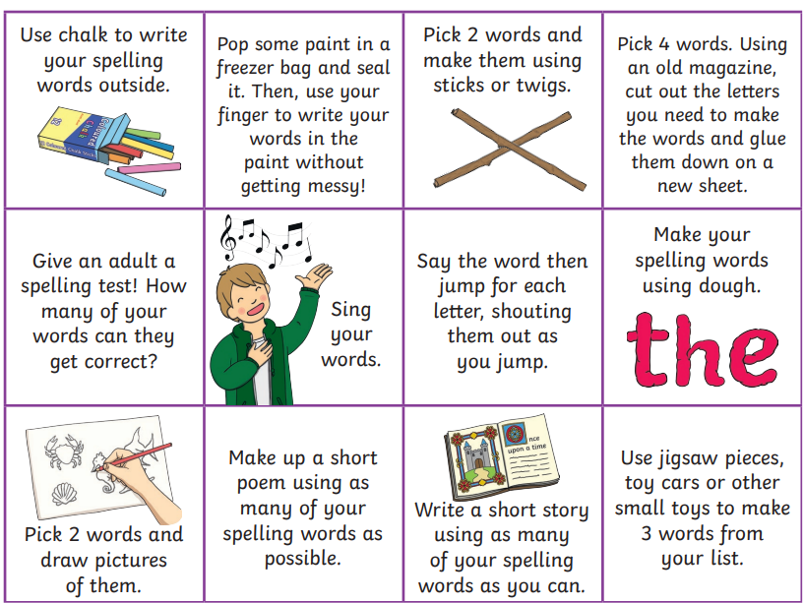

NUMERACY
Use the multiplication table and link to these websites to practice your times tables.
https://www.timestables.co.uk/
https://www.topmarks.co.uk/maths-games/hit-the-button

Multiplication Task:
Can you create your own 10x table game which can be used in class during Multiplication Masters. This could be a board game, card game or any other type you can think of. What resources do you need to play the game. Be creative and make your game fun and exciting!
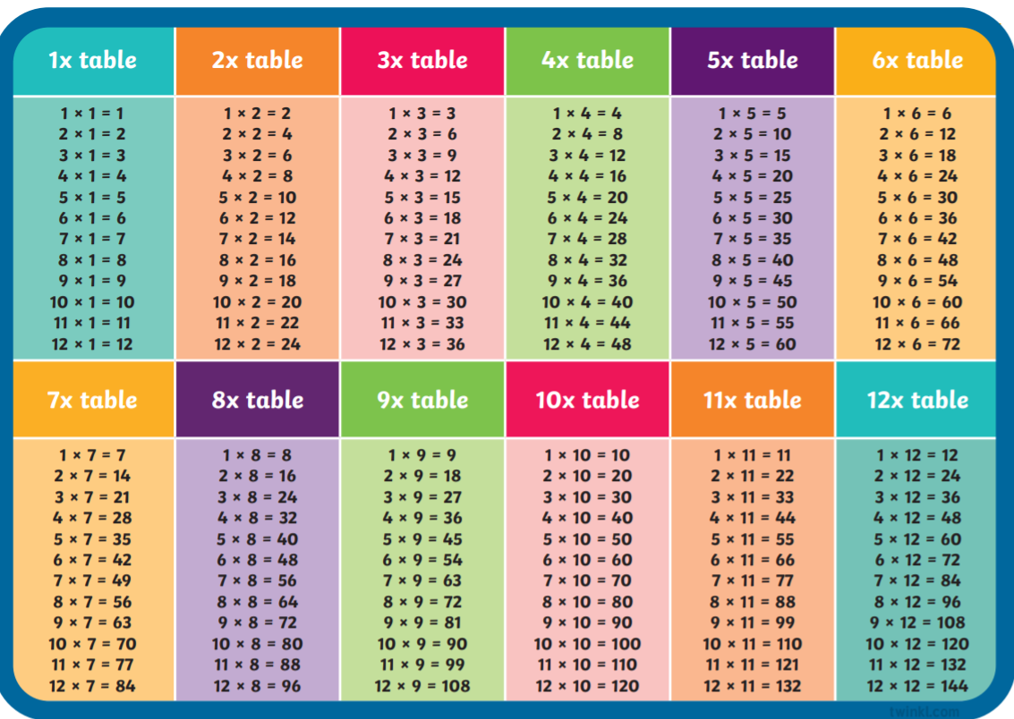

Rounding decimal numbers to the nearest whole number:
Roll a dice to create a decimal number, e.g. rolling a 3, 6 and then 2 would create the number 36.2. Round that number to the nearest whole number as shown below
36.2 36
Repeat this 10 times, creating your own set of numbers.

Rounding up to 9.9 to Nearest Whole Number
https://www.topmarks.co.uk/maths-games/rocket-rounding


READING

A book has been sent home for reading practice. Try fitting this into your nightly routines where possible.

NESSY
Use your log in for NESSY to try out the activities.

