P5 Homework Activities
Week Beginning: 05/10/26
Monday – Thursday
Try to work on some homework tasks each night. You can fit them in around your family schedule. Return your jotters to school on a Friday please.

SPELLING : Common words
Spelling Test in class for this week’s spelling words.
Group 1 | Group 2 | Group 3
Common/Tricky Words | Common/Tricky Words | Common/Tricky Words
above  breakfast  cupboard  eight  eighteen  first  hear  listen  nine  million | which  what  bring  long  three  again  these  people  too  school | have  your  only  by  are  come  of  new  said  could

- Look at the spelling words for your group, copy each word 3 times.
- Choose any 5 of words from your list, write 5 sentences using at least a capital letter, full stop. Challenge yourself to use doffernt punctuation- ?!”,’
- Try to include an adjective( decribing word) .
- If you want a challenge you can do all 10 or find the meanings of the words you don’t know!
EXTRA: Try some different activities from the grid below to help you too.
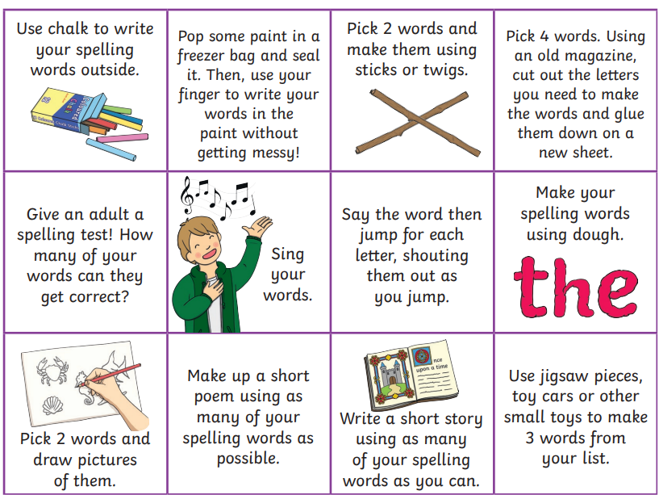

NUMERACY
Use the multiplication table and link to these websites to practice your times tables.
https://www.timestables.co.uk/
https://www.topmarks.co.uk/maths-games/hit-the-button

Multiplication Task:
Can you create your own 10x table game which can be used in class during Multiplication Masters. This could be a board game, card game or any other type you can think of. What resources do you need to play the game. Be creative and make your game fun and exciting!
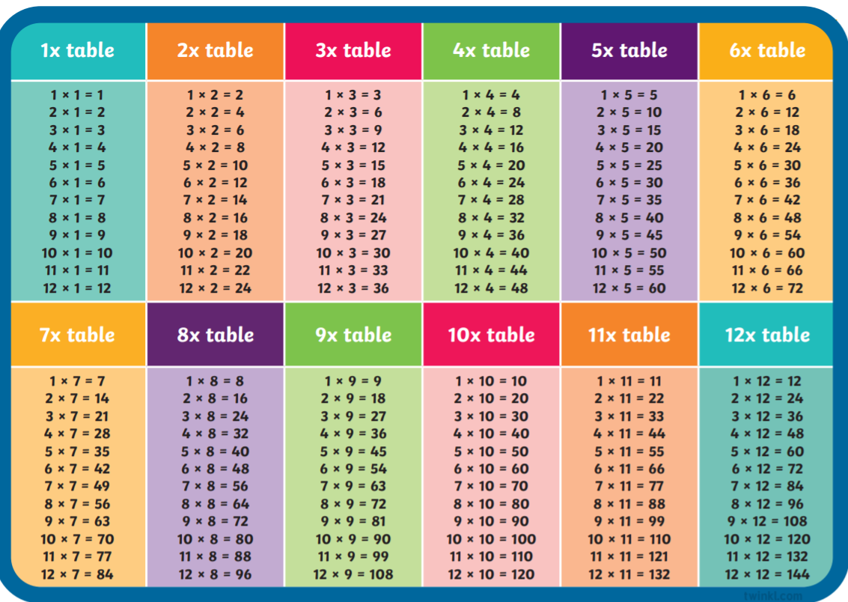

Decimal Numbers:
Complete the worksheet below. You do not have to print and cut out the monsters. You can either draw them or list their heights in order from shortest to tallest.
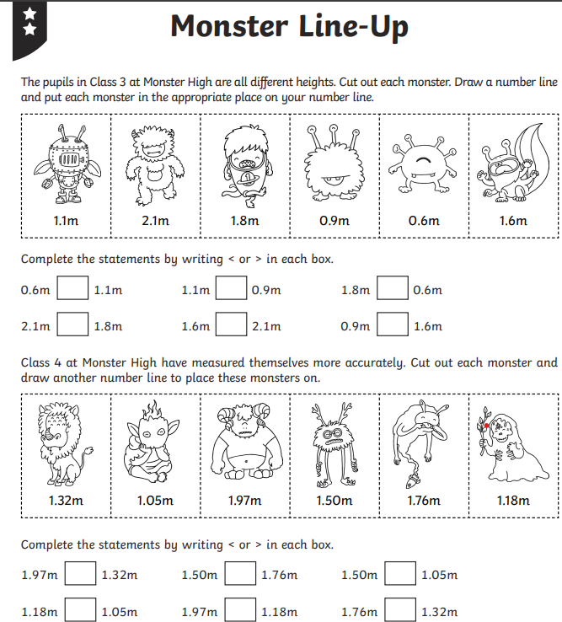

Ordering decimal numbers: Balloon Pop Ordering
https://www.sheppardsoftware.com/math/decimals/balloon-pop-ordering/

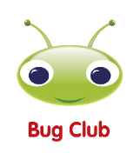
READING

A book has been sent home for reading practice. Try fitting this into your nightly routines where possible.

NESSY
Use your log in for NESSY to try out the activities.

