P5 Homework Activities
Week Beginning: 28/09/26
Monday – Thursday
Try to work on some homework tasks each night. You can fit them in around your family schedule. Return your jotters to school on a Friday please.

SPELLING : Phoneme
Spelling Test in class for this week’s spelling words.
Group 1 | Group 2 | Group 3
n  (n/nn/kn/-ne/gn/-nne) | ew/ow | wh/ph
November  neighbour  nineteen  connect  announce  annual  knight  known  everyone  design  reign  tonne | blew  flew  view  drew  nephew  owl  growl  brown  down  allow | whirl  what  whisk  when  wheel  phone  dolphin  alphabet  elephant  photo

- Look at the spelling words for your group, copy each word 3 times.
- Choose any 5 of words from your list, write 5 sentences using at least a capital letter, full stop. Challenge yourself to use doffernt punctuation- ?!”,’
- Try to include an adjective( decribing word) .
- If you want a challenge you can do all 10 or find the meanings of the words you don’t know!
EXTRA: Try some different activities from the grid below to help you too.
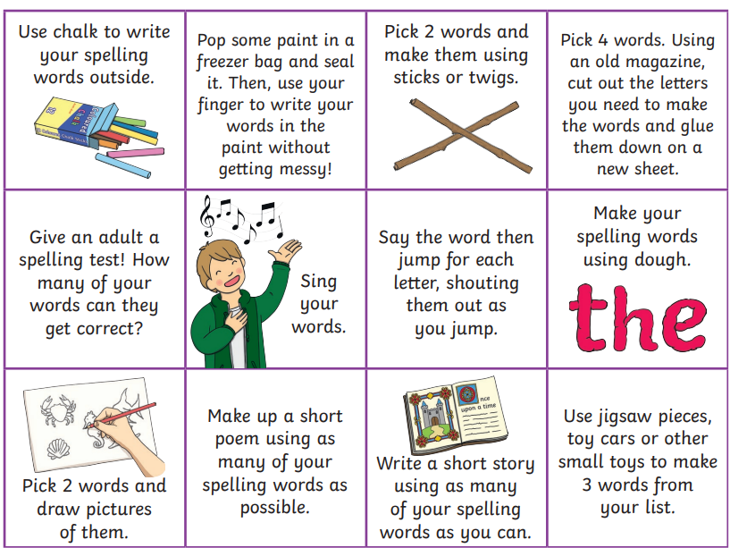

NUMERACY
Use the multiplication table and link to these websites to practice your times tables.
https://www.timestables.co.uk/
https://www.topmarks.co.uk/maths-games/hit-the-button
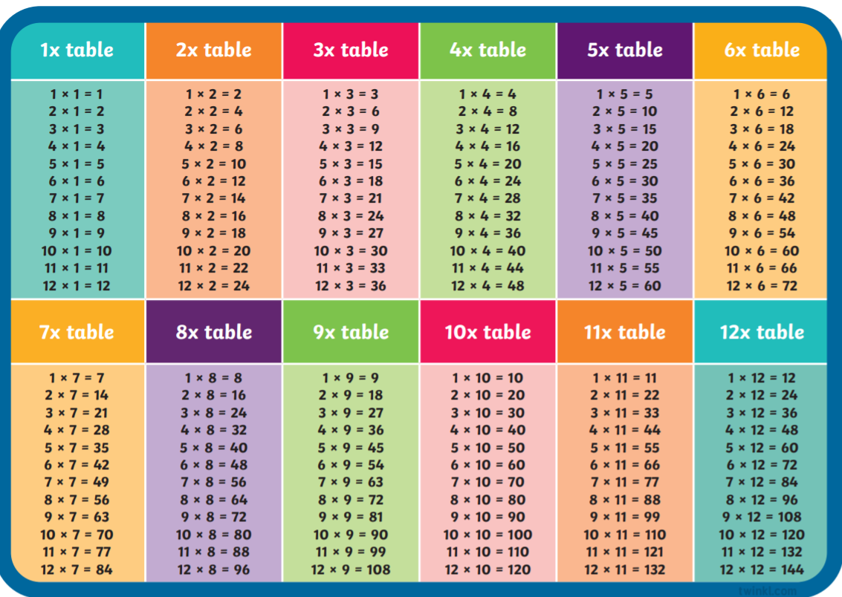
Adding and subtracting decimals:
https://www.math-play.com/Decimals-Jeopardy/decimals-jeopardy-game_html5.html

Rounding:

Use the following website to practice rounding or scan the QR code:
https://www.topmarks.co.uk/maths-games/rocket-rounding


READING

A new book has been sent home for reading practice. Try fitting this into your nightly routines where possible.
Task: Read the front cover and blurb on the back. Before you begin reading write down a prediction in your homework jotter explaining what you think the book may be about?

NESSY
Use your log in for NESSY to try out the activities.

