P5 Homework Activities
Week Beginning: 14/08/26 & 21/09/26
Mon – Thu & Tue - Fri
Try to work on some homework tasks each night. You can fit them in around your family schedule. Return your jotters to school on a Friday please. Remember the September weekend is coming up and we are off Friday 18th and Monday 21st. You will have 2 shorter weeks to work on homework and return this by Friday 25th please.

SPELLING : Phoneme
We will be working on the following words in class over the next 2 shorter weeks and a spelling test for 10 of these words will take place on Friday 25th September so please practice as many as you can. You can split the words over the 2 weeks.
Group 1 | Group 2 | Group 3
m (m/me/mm/mb/mn) |  | th/ng
September  experiment  impossible  welcome  somebody  become  swimming  comma  slammed  hammock  thumb  climb  plumb  breadcrumb  honeycomb  autumn  column | toil  join  boil  spoil  foil  noise  point  pause  cause  haunt  flaunt  launch  dinosaur  astronaut | thin  thick  this  that  moth  bath  with  king  bring  string  sting  belong  strong  along

- Look at the spelling words for your group, copy each word 3 times.
- Choose any 5 of words from your list, write 5 sentences using at least a capital letter, full stop. Challenge yourself to use doffernt punctuation- ?!”,’
- Try to include an adjective( decribing word) .
- If you want a challenge you can do all words or find the meanings of the words you don’t know!
EXTRA: Try some different activities from the grid below to help you too.
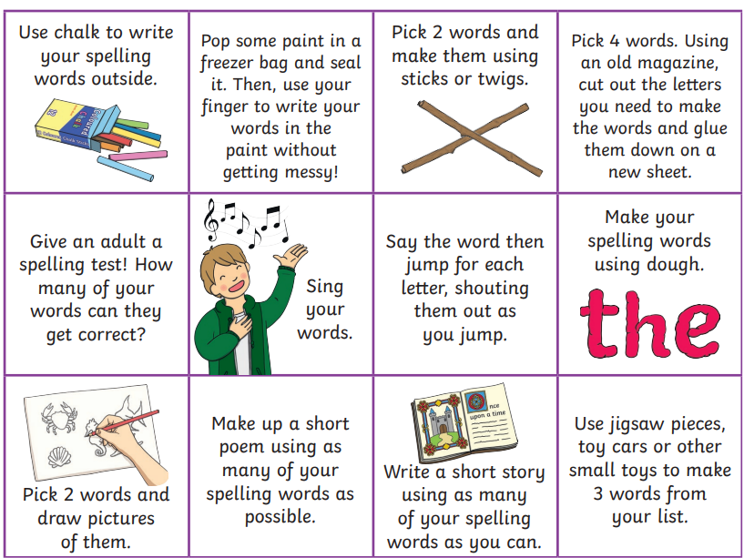

NUMERACY
Use the multiplication table and link to these websites to practice your times tables.
https://www.timestables.co.uk/
https://www.topmarks.co.uk/maths-games/hit-the-button
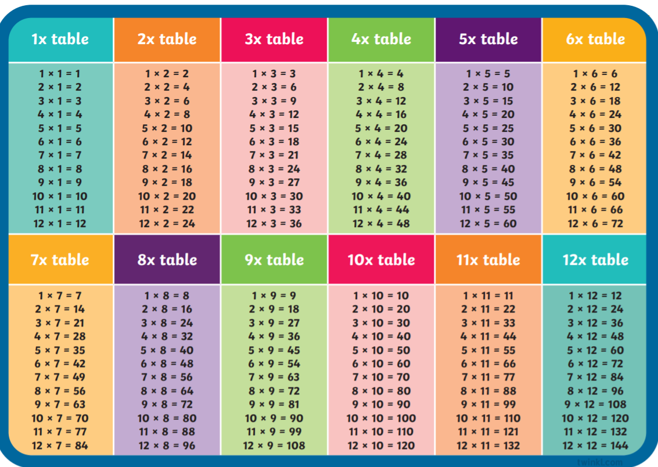
Rounding:
Copy the table and round the following numbers to the nearest 10, 100 and 100
Question number | To the nearest 10 | To the nearest 100 | To the nearest 1000
- 76
- 561
- 819
- 127
- 655
- 1004
- 3298
- 7382
- 2226
- 8983
- 6605



READING

Books have been sent home for reading practice. Try fitting this into your nightly routines where possible.

NESSY
Use your log in for NESSY to try out the activities.

