P5/6 Homework Activities
Week Beginning: 23/03/26
Monday – Thursday
Try to work on some homework tasks each night. You can fit them in around your family schedule. Return your jotters to school on a Friday please.
SPELLING : Phoneme
Spelling Test in class for this week’s spelling words.
Group 1 | Group 2 | Group 3
accordian  accessory  accuracy  quantity  quadrant  aqueduct  chequering  antiques  grotesque  torqued | clock  chick  peach  chicken  cricket  pocket  bucket  crunch  stitch  witch | cake  kind  kick  clock  black  truck  cook  knock  snack  skate

- Look at the spelling words for your group, copy each word 3 times.
- Choose any 5 of words from your list, write 5 sentences using at least a capital letter, full stop. Challenge yourself to use differnt punctuation- ?!”,’
- Try to include an adjective( decribing word) .
- If you want a challenge you can do all 10!
- EXTRA- can you find the meanings of any words you don’t know?

ANCIENT EGYPT
Over this session you could try out some activities from this planner, this will be an opportunity to do some personal learning and research.
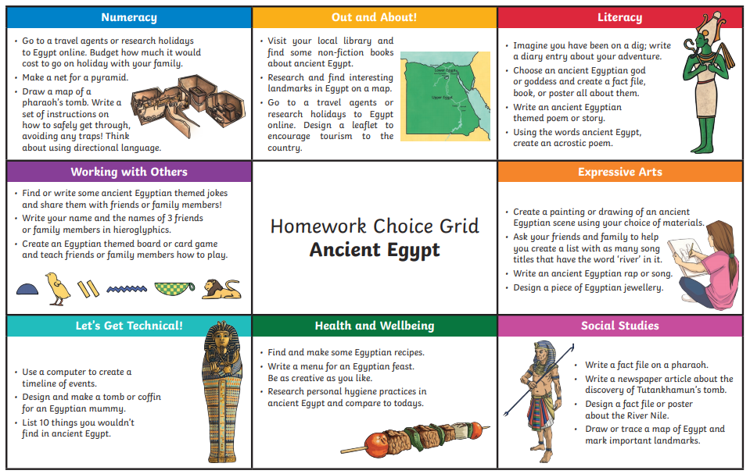

READING AND NUMERACY
Use your log in for NESSY to try out the activities.


