P5 Homework Activities
Week Beginning: 16/03/26
Monday – Thursday
Try to work on some homework tasks each night. You can fit them in around your family schedule. Return your jotters to school on a Friday please.
S
ANCIENT EGYPT
Over this session you could try out some activities from this planner, this will be an opportunity to do some personal learning and research.

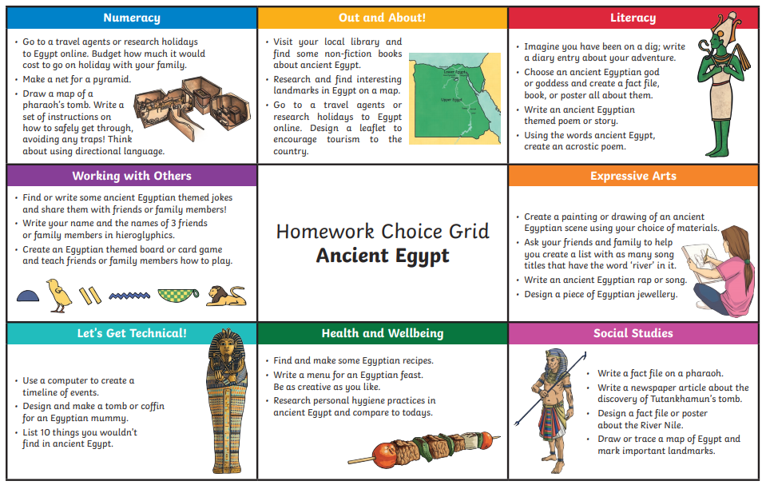

READING AND NUMERACY
Use your log in for NESSY to try out the activities.


