https://www.watchkin.com/cc0fcc475d THE GRINCH
https://www.watchkin.com/b49133a28f Feliz Navidad
https://www.watchkin.com/e5da5e364c Nativity
https://www.youtube.com/results?sp=mAEB&search_query=sparkle+and+shine Sparkle and Shine
Drongan Express word separate sheet
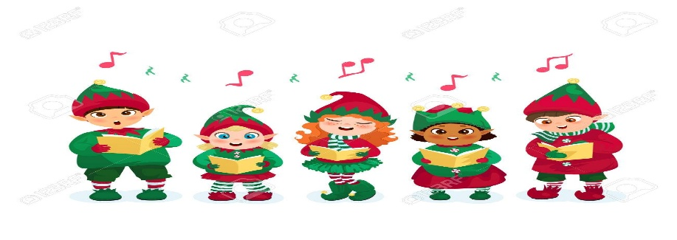
This Photo by Unknown Author is licensed under CC BY-NC-ND

