**P5 Homework Activities**

**Week Beginning: 06/10/25**

**Monday – Thursday** 

Try to work on some homework tasks each night. You can fit them in around your family schedule. Return your jotters to school on a **Friday** please.

**SPELLING :**

**Spelling Test in class for this week’s spelling words.**

|  |  |  |
| --- | --- | --- |
| **Group 1** | **Group 2** | **Group 3** |
| **dh** | **de** | **D dd** |
| **adhibit**  **jodhpurs**  **adhesive**  **adhesion**  **ceilidhs**  **Buddha**  **Buddhism**  **Buddhology**  **headhunter**  **adhere** | **aide**  **blade**  **crude**  **abode**  **erode**  **evade**  **Clyde**  **pride**  **spade**  **trade** | **mud**  **muddy**  **odd**  **add**  **adding**  **duck**  **bird**  **bend**  **deep**  **dash** |

1. **Look at the spelling words for your group, copy each word 3 times.**
2. **Choose any 5 of words from your list, write 5 sentences using at least a capital letter, full stop. Challenge yourself to use doffernt punctuation- ?!”,’**
3. **Try to include an adjective( decribing word) .**
4. **If you want a challenge you can do all 10 or find the meanings of the words you don’t know!**

**EXTRA: Try some different activities from the grid below to help you too.**

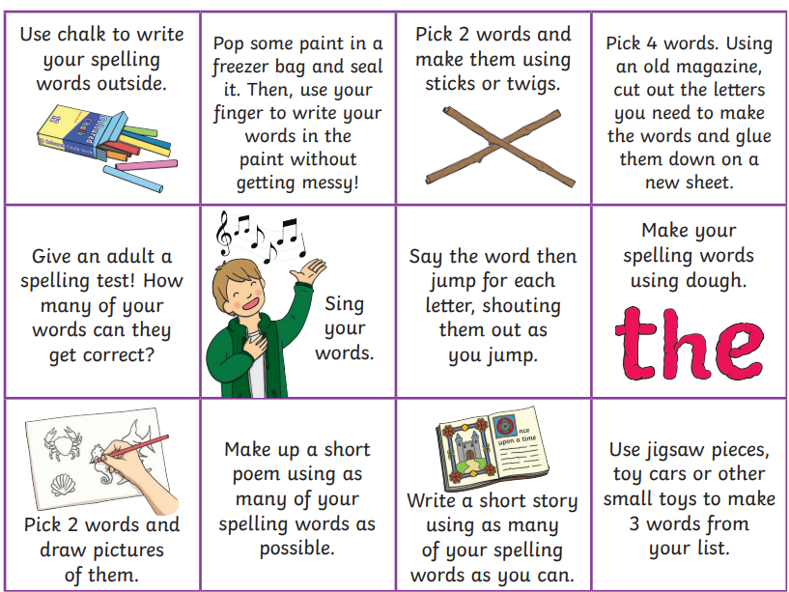

**READING & COMPREHENSION** 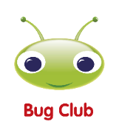

**NUMERACY**

Use the multiplication table and link to this game and songs to practice your times tables for your Ninja Challenge.

<https://www.timestables.co.uk/games/> You can practice on this too.

# <https://www.youtube.com/watch?v=oPINS56lDes> Multiplication Songs for Children (Official Video) Multiply Numbers 1 through 12 for Kids



