**P5 Homework Activities**

**Week Beginning: 23/09/25**

**Monday – Thursday** 

Try to work on some homework tasks each night. You can fit them in around your family schedule. Return your jotters to school on a **Friday** please.

**SPELLING : Phoneme -ae**

**Spelling Test in class for this week’s spelling words.**

|  |  |  |
| --- | --- | --- |
| **Group 1** | **Group 2** | **Group 3** |
|  |  |  |
| **aeroplane**  **practising**  **frightened**  **experiment**  **previous**  **butterflies**  **continuing**  **wonderfully**  **satisfaction**  **understandable** | **across**  **friends**  **river**  **mouse**  **eight**  **balloon**  **almost**  **below**  **music**  **paper** | **the**  **they**  **them**  **that**  **face**  **full**  **frog**  **case**  **call**  **corn** |

1. **Look at the spelling words for your group, copy each word 3 times.**
2. **Choose any 5 of words from your list, write 5 sentences using at least a capital letter, full stop. Challenge yourself to use doffernt punctuation- ?!”,’**
3. **Try to include an adjective( decribing word) .**
4. **If you want a challenge you can do all 10!**

**EXTRA: Try some different activities from the grid below to help you too.**

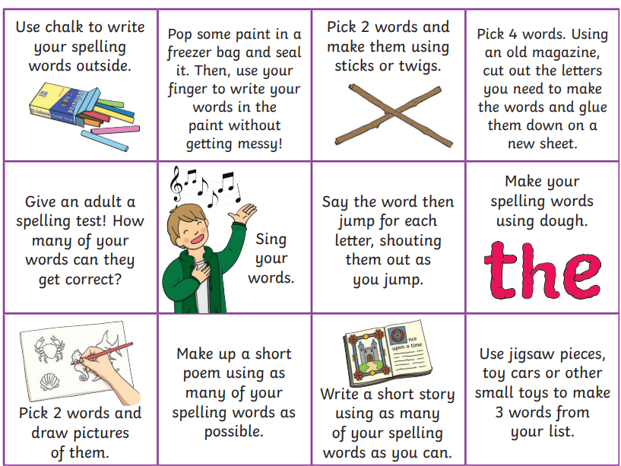

**READING & COMPREHENSION** 

**Growth Mindset Class Assembly-**

**Please practice your parts for the class assembly in October. Practice song using words in the jotter.**

**NUMERACY**

Use the multiplication table and link to this game and songs to practice your times tables for your Ninja Challenge.

<https://www.timestables.co.uk/games/> You can practice on this too.

# <https://www.youtube.com/watch?v=oPINS56lDes> Multiplication Songs for Children (Official Video) Multiply Numbers 1 through 12 for Kids



