**P5 Homework Activities**

**Week Beginning: 08/09/25**

**Monday – Thursday** 

Try to work on some homework tasks each night. You can fit them in around your family schedule. Return your jotters to school on a **Friday** please.

**SPELLING : Phoneme -ae**

**Spelling Test in class for this week’s spelling words.**

|  |  |  |
| --- | --- | --- |
| **Group 1** | **Group 2** | **Group 3** |
| **ey ea** | **ey ea** | **ck** |
| **chocolatey**  **fiddley**  **multistorey**  **honeycomb**  **valley**  **breakfast**  **greatest**  **steakhouse**  **breaking**  **daybreak** | **they**  **obey**  **money**  **honey**  **monkey**  **break**  **breaking**  **great**  **greater**  **steak** | **back**  **sack**  **neck**  **peck**  **kick**  **sick**  **rock**  **sock**  **duck**  **suck** |

1. **Look at the spelling words for your group, copy each word 3 times.**
2. **Choose any 5 of words from your list, write 5 sentences using at least a capital letter, full stop. Challenge yourself to use doffernt punctuation- ?!”,’**
3. **Try to include an adjective( decribing word) .**
4. **If you want a challenge you can do all 10!**

**EXTRA: Try some different activities from the grid below to help you too.**

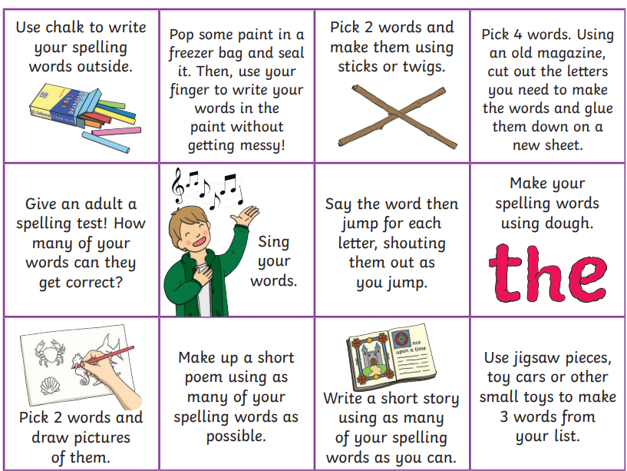

**READING & COMPREHENSION** 

**Growth Mindset Class Assembly-**

**Please practice your parts for the class assembly on Wednesday 1st October.**

**NUMERACY**

Use the multiplication table and link to this game and songs to practice your times tables for your Ninja Challenge.

<https://www.timestables.co.uk/games/> You can practice on this too.

# <https://www.youtube.com/watch?v=oPINS56lDes> Multiplication Songs for Children (Official Video) Multiply Numbers 1 through 12 for Kids



