P 5 Homework Activities
Week Beginning: 02/12/24
School Christmas Fayre- Tuesday 3rd- main hall- 6.00 pm.
Youtube: Taylor Swift Love Story Google song and practise it for closing number at
Cinderella & Rockerfella
Literacy : Use these pictures to write sentences and create a Winter acrostic poem.
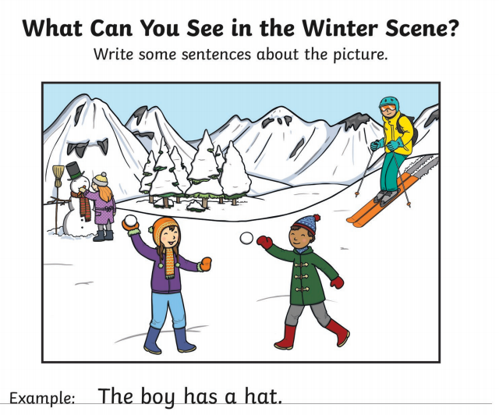 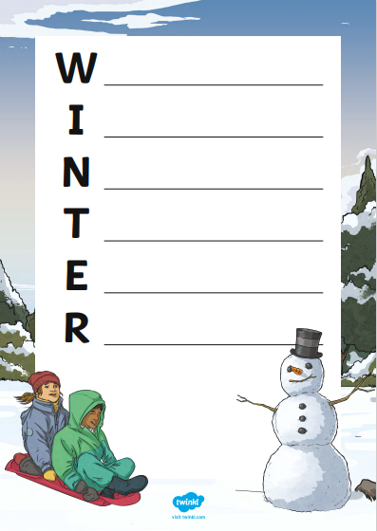***********************************************************************************
 READING & COMPREHENSION
Bugclub Books- please read the allocated class book. You can do this with an adult or a sibling. Spread the reading over the 2 weeks and practise fluency and expression. Try to look for different punctuation marks, speech marks. TALK about the book with someone in your household. Did you like it? Favourite part? Did you learn any new vocabulary?

****************************************************************************************************

NUMERACY
Try out some simple addition and complete the fitness challenge. Keep fit and have some fun!
https://watchkin.com/523621234c

Check out these Subtraction Videos.
https://watchkin.com/a6786c9c10 Subtraction TU
https://watchkin.com/f3733d010d Subtraction HTU

Use the multiplication table and link to this game and songs to practice your times tables for your Ninja Challenge.
https://www.timestables.co.uk/games/ You can practice on this too.

https://www.youtube.com/watch?v=oPINS56lDes Multiplication Songs for Children (Official Video) Multiply Numbers 1 through 12 for Kids

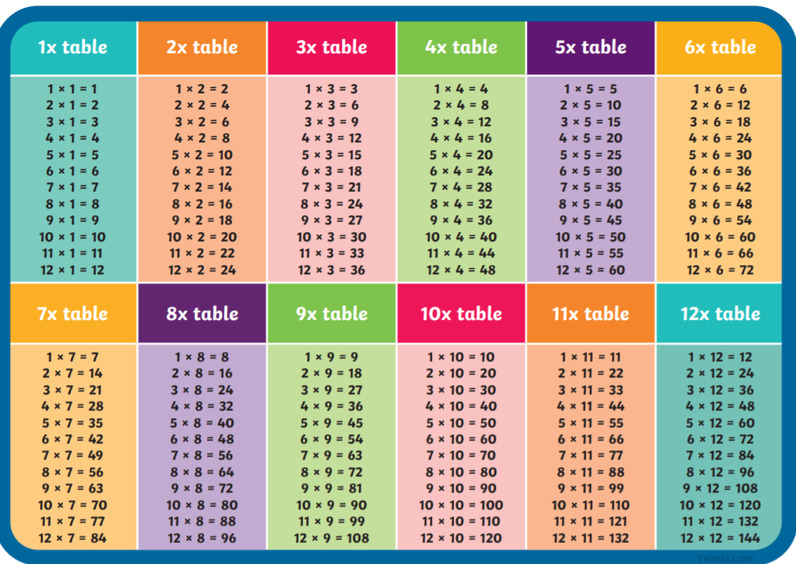

https://www.timestables.co.uk/games/ You can practice on this too.
Check out these websites for some other activities you could try out throughout the session.
https://www.coolmathgames.com/
https://www.topmarks.co.uk/
https://www.worldofdavidwalliams.com/
https://www.bbc.co.uk/bitesize

