**P5B Homework Activities**

**Week Beginning: 30/09/24**

**Monday – Thursday** 

Try to work on some homework tasks each night. You can fit them in around your family schedule. Return your jotters to school on a **Friday** please.

**SPELLING :**

**Spelling Test in class for this week’s spelling words.**

|  |  |  |
| --- | --- | --- |
| **Group 1** | **Group 2** | **Group 3** |
|  |  |  |
| **brightness**  **tightening**  **recognised**  **politeness**  **myself**  **decided**  **unsliced**  **untied**  **replying**  **nightmare** | **high**  **night**  **slice**  **wipe**  **pie**  **tied**  **frying**  **reply**  **mice**  **myself** | **mice**  **nice**  **rice**  **wipe**  **time**  **tie**  **die**  **lie**  **fry**  **why** |

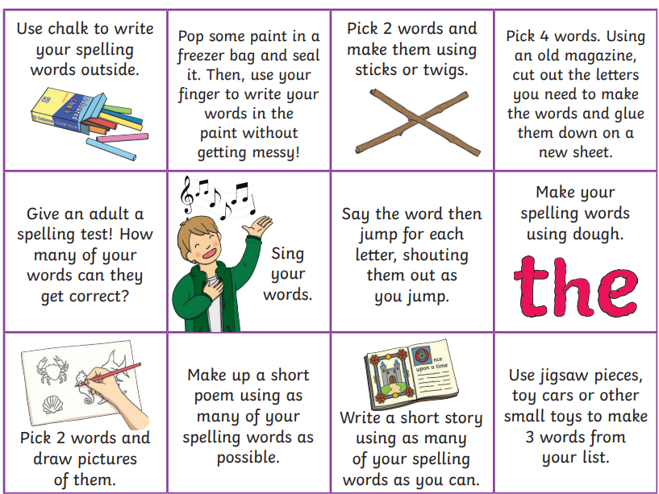

* **Look at the spelling words for your group, copy each word 3 times.**
* choose some activities from your spelling menu to learn them .
* Try to do at least 3 different activities from the list, but you can do more to challenge yourself !
* **READING & COMPREHENSION** 
* **Bugclub Books- please read the allocated class book. You can do this with an adult or a sibling. Spread the reading over the 2 weeks and practise fluency and expression. Try to look for different punctuation marks, speech marks. TALK about the book with someone in your household. Did you like it? Favourite part? Did you learn any new vocabulary?**

**NUMERACY**

**Try out some simple addition and complete the fitness challenge.**

**Keep fit and have some fun!**

[**https://watchkin.com/523621234c**](https://watchkin.com/523621234c)

Check out these Subtraction Videos.

<https://watchkin.com/a6786c9c10> Subtraction TU

<https://watchkin.com/f3733d010d> Subtraction HTU

Use the multiplication table and link to this game and songs to practice your times tables for your Ninja Challenge.

<https://www.timestables.co.uk/games/> You can practice on this too.

# <https://www.youtube.com/watch?v=oPINS56lDes> Multiplication Songs for Children (Official Video) Multiply Numbers 1 through 12 for Kids

