**P5B Homework Activities**

**Week Beginning: 16/09/23**

**Monday – Thursday** 

Try to work on some homework tasks each night. You can fit them in around your family schedule. Return your jotters to school on a **Friday** please.

Holiday on Friday 20th and Monday 23rd September.

**SPELLING : Tricky words**

**Spelling Test in class for this week’s spelling words.**

|  |  |  |
| --- | --- | --- |
| **Group 1** | **Group 2** | **Group 3** |
|  |  |  |
| **above**  **breakfast**  **cupboard**  **eight**  **eighteen**  **experiment**  **previous**  **hear**  **listen**  **nine**  **nineteen**  **million**  **surprise**  **precious**  **morning** | **shoulder**  **they**  **called**  **round**  **continue**  **previous**  **morning**  **allow**  **our**  **asked**  **state**  **weather**  **who**  **where**  **what** | **have**  **your**  **only**  **by**  **are**  **come**  **of**  **new**  **said**  **could**  **her**  **before**  **day**  **away**  **today** |

1. **Look at the spelling words for your group, copy each word 3 times.**
2. **Choose 5 of words from your list, write 5 sentences using a capital letter, full stop. Try to include an adjective( decribing word) .**

**EXTRA: Try some different activities from the grid below to help you too.**

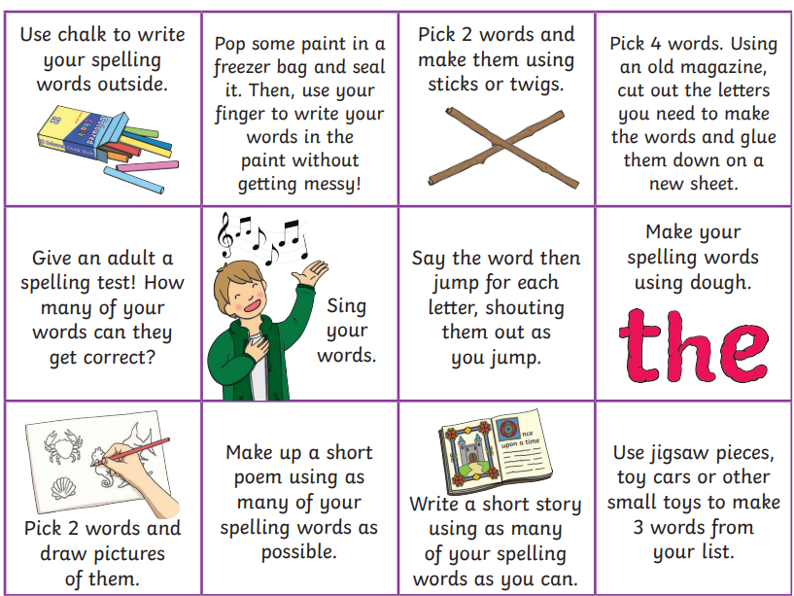

**READING & COMPREHENSION** 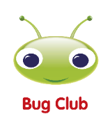

**Bugclub Books- please read the allocated class book. You can do this with an adult or a sibling. Spread the reading over the 2 weeks and practise fluency and expression. Try to look for different punctuation marks, speech marks. TALK about the book with someone in your household. Did you like it? Favourite part? Did you learn any new vocabulary?**

**NUMERACY**

Use the multiplication table and link to this game and songs to practice your times tables for your Ninja Challenge.

<https://www.timestables.co.uk/games/> You can practice on this too.

# <https://www.youtube.com/watch?v=oPINS56lDes> Multiplication Songs for Children (Official Video) Multiply Numbers 1 through 12 for Kids

