P 5 Homework Activities
Week Beginning: 04/12/23
School Christmas Fayre- Tuesday 5th- main hall- 6.00 pm.
Panto- Wednesday 6th at Ayr Gaiety Theatre.
Christmas lunch -Thursday 7th.
Literacy : Use these pictures to write sentences and create a Winter acrostic poem.
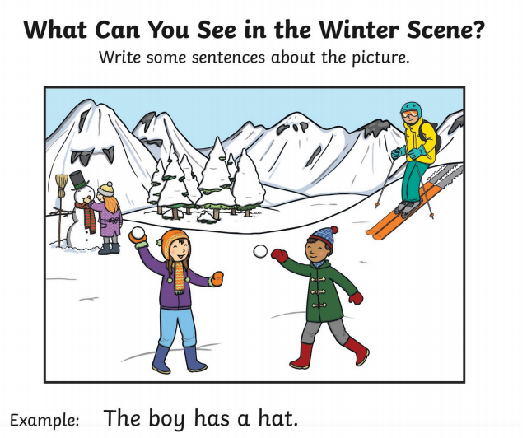 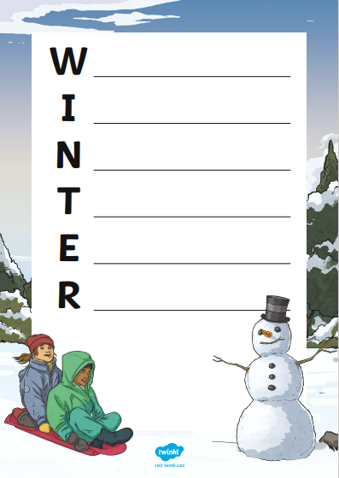***********************************************************************************
READING & COMPREHENSION
BugClub-read and complete the allocated class book.
Red Stars- Big Cats
Blue Stars- Caring For Exotic Animals
Green Stars- Birthdays Around The world

****************************************************************************************************

NUMERACY
Try out some simple addition and complete the fitness challenge.
Keep fit and have some fun!
https://watchkin.com/523621234c

Check out these Subtraction Videos.
https://watchkin.com/a6786c9c10 Subtraction TU
https://watchkin.com/f3733d010d Subtraction HTU

Use the multiplication table and link to this game and songs to practice your times tables for your Ninja Challenge.
https://www.timestables.co.uk/games/ You can practice on this too.

https://www.youtube.com/watch?v=oPINS56lDes Multiplication Songs for Children (Official Video) Multiply Numbers 1 through 12 for Kids

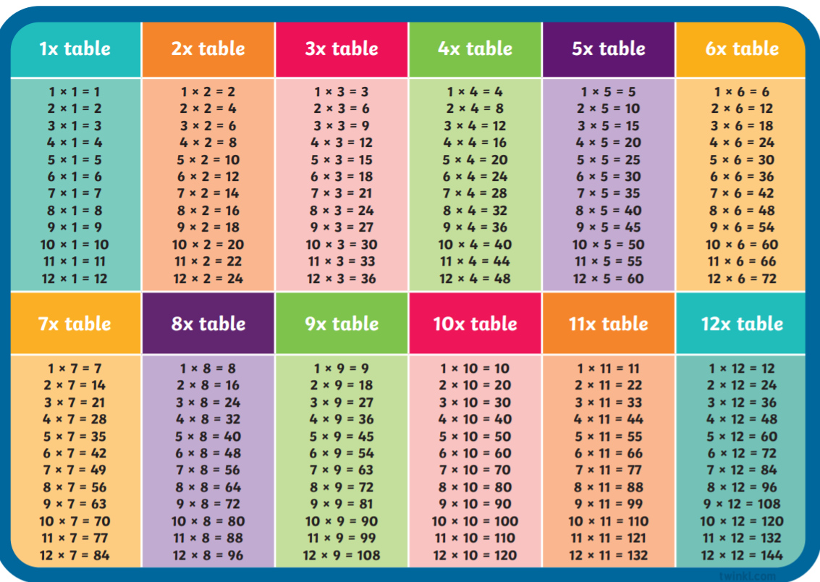

https://www.timestables.co.uk/games/ You can practice on this too.
Check out these websites for some other activities you could try out throughout the session.
https://www.coolmathgames.com/
https://www.topmarks.co.uk/
https://www.worldofdavidwalliams.com/
https://www.bbc.co.uk/bitesize

