P5A Homework Activities
Week Beginning: 06/11/23
Monday – Thursday
Try to work on some homework tasks each night. You can fit them in around your family schedule. Return your jotters to school on a Friday please.
SPELLING :
Spelling Test in class for this week’s spelling words.
Group 1 | Group 2 | Group 3
- elephone  - wrote  - groaning  - toasting  - tomorrow  - following  - potatoes  - tomatoes  - shallow  - whole | - hope  - woke  - coal  - moan  - bowling  - window  - heroes  - goes  - road  - alone | - bone  - hole  - road  - coal  - soak  - bowl  - own  - snow  - toe  - foe

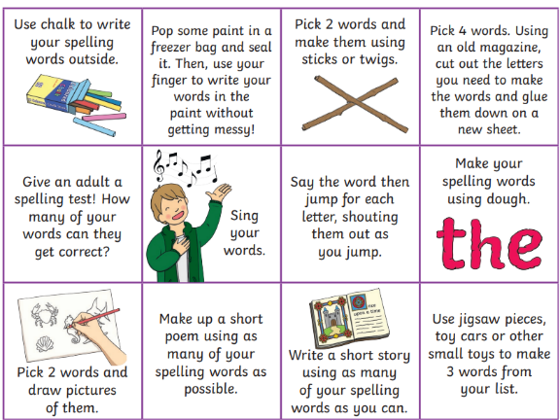
- Look at the spelling words for your group, copy each word 3 times.
- choose some activities from your spelling menu to learn them .
- Try to do at least 3 different activities from the list, but you can do more to challenge yourself !

READING & COMPREHENSION
BugClub-read and complete the allocated class book.
Red Stars- Unexpected
Blue Stars- Birds of Prey
Green Stars- Epic Adventures

NUMERACY
Try out some simple addition and complete the fitness challenge.
Keep fit and have some fun!
https://watchkin.com/523621234c

Check out these Subtraction Videos.
https://watchkin.com/a6786c9c10 Subtraction TU
https://watchkin.com/f3733d010d Subtraction HTU

Use the multiplication table and link to this game and songs to practice your times tables for your Ninja Challenge.
https://www.timestables.co.uk/games/ You can practice on this too.

https://www.youtube.com/watch?v=oPINS56lDes Multiplication Songs for Children (Official Video) Multiply Numbers 1 through 12 for Kids

