P5A Homework Activities
Week Beginning: 24/10/23-30/10/23
Monday – Thursday
Try to work on some homework tasks each night. You can fit them in around your family schedule. Return your jotters to school on a Friday please.
SPELLING :
Spelling Test in class for this week’s spelling words.
Group 1 | Group 2 | Group 3
- happy  - word  - lady  - paper  - window  - floor  - shoe  - being  - coming  - jumped  - started  - used  - walked  - woke  - only | - accident  - below  - cloudy  - eleven  - football  - group  - holiday  - I’m  - I’ve  - playtime  - practising  - whispered  - emotion  - knew  - biscuit | - each  - ask  - year  - eat  - yellow  - grow  - again  - food  - blue  - best  - number  - other  - very  - took  - fast

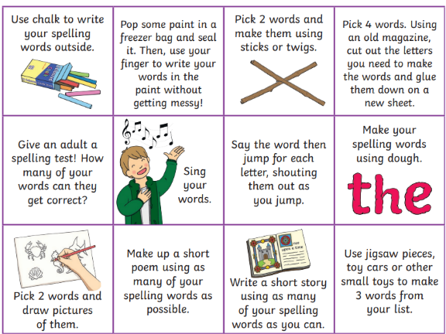
- Look at the spelling words for your group, copy each word 3 times.
- choose some activities from your spelling menu to learn them .
- Try to do at least 3 different activities from the list, but you can do more to challenge yourself !

READING & COMPREHENSION
BugClub-read and complete the allocated class book.
Red Stars- Cloud Rider
Blue Stars- All At Sea
Green Stars- Gloopy food

NUMERACY
Try out some simple addition and complete the fitness challenge.
Keep fit and have some fun!
https://watchkin.com/523621234c

Check out these Subtraction Videos.
https://watchkin.com/a6786c9c10 Subtraction TU
https://watchkin.com/f3733d010d Subtraction HTU

Use the multiplication table and link to this game and songs to practice your times tables for your Ninja Challenge.
https://www.timestables.co.uk/games/ You can practice on this too.

https://www.youtube.com/watch?v=oPINS56lDes Multiplication Songs for Children (Official Video) Multiply Numbers 1 through 12 for Kids

