P5B Homework Activities
Week Beginning: 18/09/23
Monday – Thursday
Try to work on some homework tasks each night. You can fit them in around your family schedule. Return your jotters to school on a Friday please.
Holiday on Friday 22nd and Monday 25th September.
SPELLING : Tricky words
Spelling Test in class for this week’s spelling words.
Group 1 | Group 2 | Group 3
shoulder  they  called  round  continue  previous  morning  allow  our  asked  state  weather  who  where  what | above  breakfast  cupboard  eight  eighteen  experiment  first  hear  listen  nine  nineteen  million  surprise  care  busy | have  your  only  by  are  come  of  new  said  could  her  before  day  away  today

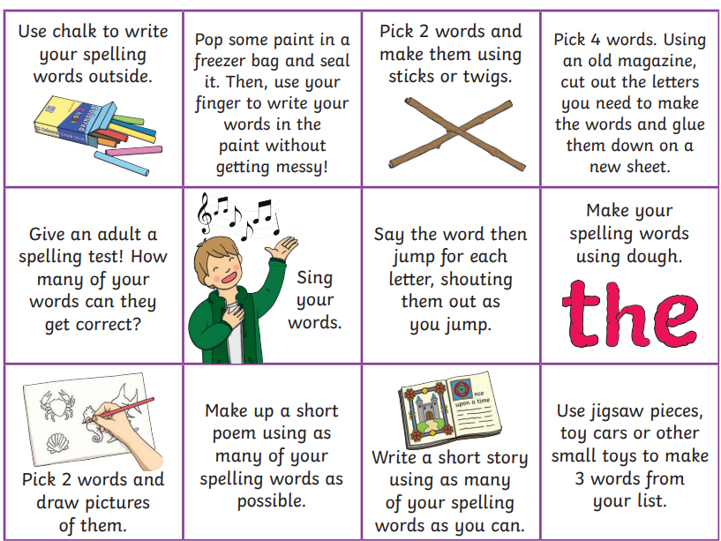
- Look at the spelling words for your group, copy each word 3 times.
- choose some activities from your spelling menu to learn them .
- Try to do at least 3 different activities from the list, but you can do more to challenge yourself !

READING & COMPREHENSION
BugClub-read and complete the allocated class book.
Red Stars- 101 ways to Beat Boredom
Blue Stars- Superpet
Green Stars- Wallace & Gromit and the Soccamatic

NUMERACY
Use the multiplication table and link to this game and songs to practice your times tables for your Ninja Challenge.
https://www.timestables.co.uk/games/ You can practice on this too.

https://www.youtube.com/watch?v=oPINS56lDes Multiplication Songs for Children (Official Video) Multiply Numbers 1 through 12 for Kids

