P5B Homework Activities
Week Beginning: 11/09/23
Monday – Thursday
Try to work on some homework tasks each night. You can fit them in around your family schedule. Return your jotters to school on a Friday please.
SPELLING : Phoneme -ae
Spelling Test in class for this week’s spelling words.
Group 1 | Group 2 | Group 3
ey ea | ey ea | ck
chimney  turkey  honey  honeycomb  valley  breakfast  greatest  steaks  breaking  daybreak | they  obey  money  honey  monkey  break  breaking  great  greater  steak | back  sack  neck  peck  kick  sick  rock  sock  duck  suck

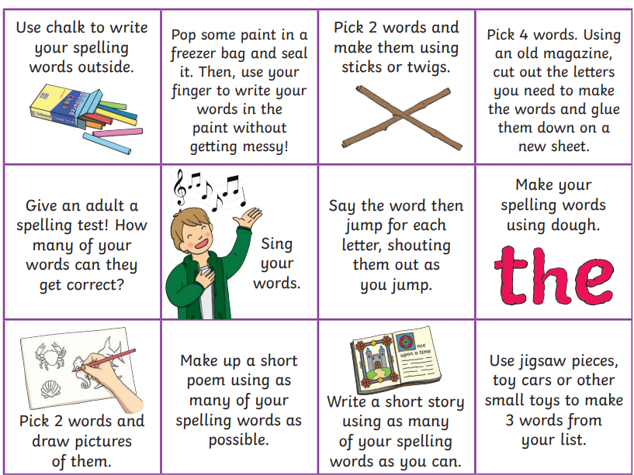
- Look at the spelling words for your group, copy each word 3 times.
- choose some activities from your spelling menu to learn them .
- Try to do at least 3 different activities from the list, but you can do more to challenge yourself !

READING & COMPREHENSION
BugClub-read and complete the allocated class book.
Red Stars- The Quigley’s Have Got Talent
Blue Stars- Wallace & Gromit and the Soccamatic
Green Stars- Stop That Dog

NUMERACY
Use the multiplication table and link to this game and songs to practice your times tables for your Ninja Challenge.
https://www.timestables.co.uk/games/ You can practice on this too.

https://www.youtube.com/watch?v=oPINS56lDes Multiplication Songs for Children (Official Video) Multiply Numbers 1 through 12 for Kids

