P 5 Homework Activities
Week Beginning: 04/09/23
Monday – Thursday
Try to work on some homework tasks each night. You can fit them in around your family schedule. Return your jotters to school on a Friday please.
SPELLING : Phoneme -ae
Spelling Test in class for this week’s spelling words.
- Group1-chocolate/mistake/ amazed/holidaying/birthdays/yesterday/ downstairs/ explaining/complaining/unafraid

- Group 2- chocolate/mistake/ amazed/holidaying/birthdays/yesterday/ downstairs/ explaining/complaining/unafraid

- Group 3- face/rage/date/train/stray/play/air/airport/paid/rain

- Look at the spelling words for your group, copy each word 3 times.
- Choose some activities from this list to help you learn them .
- Try to do at least 3 different activities from the list, but you can do more to challenge yourself !
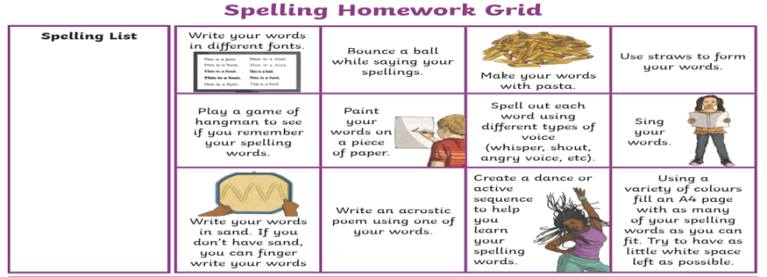
READING & COMPREHENSION
Bugclub-read and complete the allocated class book.
Red Stars- The Quigley’s Have Got Talent
Blue Stars- Wallace & Gromit and the Soccamatic
Green Stars- Stop That Dog

NUMERACY Use the multiplication table and link to this game and songs to practice your times tables for your Ninja Challenge.
https://www.timestables.co.uk/games/ You can practice on this too.

https://www.youtube.com/watch?v=oPINS56lDes Multiplication Songs for Children (Official Video) Multiply Numbers 1 through 12 for Kids

