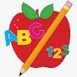Primary 2 Homework
Week Beginning: 26th October 2026
Here is a guide to help you for this week. You can choose how to organise your tasks to suit what works for you.
Please bring book bags to school every day. They will be collected in on a Friday as there will not be any homework at the weekend. If you feel you want to continue with some of the homework over the weekend, please just let me know. *Your child can use their homework jotter for any writing they do. Spelling words (these will be tested on a Friday along with the common words).
 | Literacy | Numeracy
 | Joined Phonemes  This week we are learning about oi.  Spelling words (these will be tested on a Friday along with the common words).  boil spoil foil toilet join moist  Write your words across and down the way, eg.  s p o i l  p  o  i  l  Pick at least one word to make a sentence with.  The phonemes your child should know are –  Group 1 – ay, ea (as in leaf), ow (as in snow)  Group 2 – ue, aw   | Time  We are currently revising o’clock times for digital and analogue clocks, before we move onto other times. Click on the link below to play the telling the time game, click option 1 (o’clock times).  https://mathsframe.co.uk/en/resources/resource/116/telling-the-time  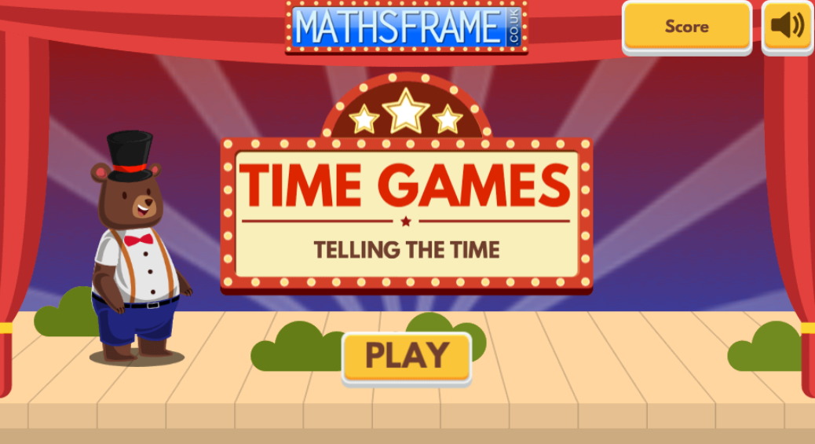  Click on the links below to sing the days of the week and months of the year songs.  https://www.youtube.com/watch?v=mXMofxtDPUQ&list=RDmXMofxtDPUQ&start_radio=1  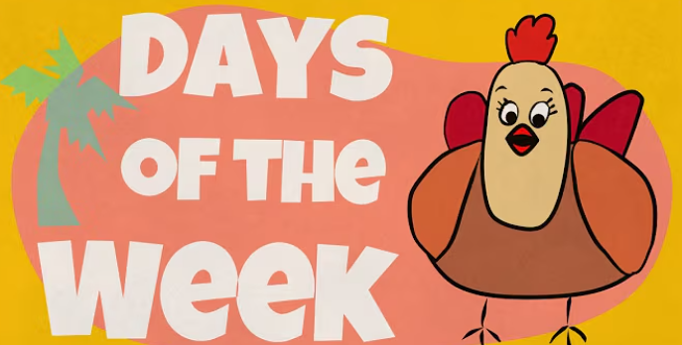  https://www.youtube.com/watch?v=Fe9bnYRzFvk&list=RDFe9bnYRzFvk&start_radio=1  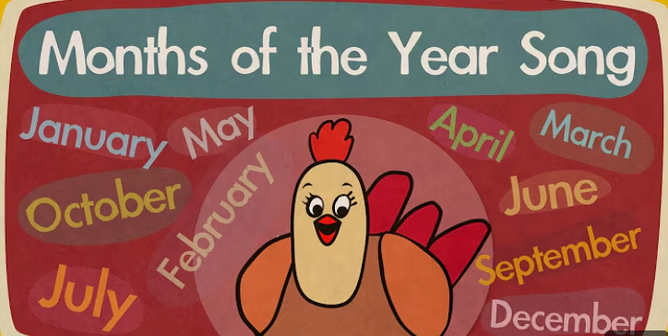
Common Words
The new common words for this week are
their some then last

Practise writing your words in lower case and upper case letters – their THEIR

Group 1 words - day away always today each ask year eat yellow grow again food

Group 2 words – blue best number other very took fast there

*Continue to practise these words to make sure your child can read and spell them.
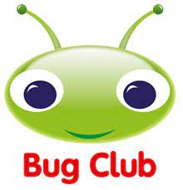

Your child will get their books home in their book bag when they have completed them in class.
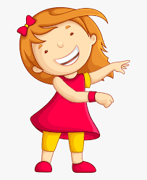Remember to have lots of fun! 

