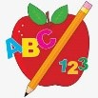 Primary 1 Homework
Week Beginning: 26th October 2026

Here is a guide to help you for this week. You can choose how to organise your tasks to suit what works for you.

Please bring book bags to school every day. They will be collected in on a Friday as there will not be any homework at the weekend. If you feel you want to continue some of the homework over the weekend, please ask for your child’s book bag.

 | Literacy | Numeracy
 | Phonics  Most children are becoming very confident with letters taught and are informally exploring all letters. They should still aim to remember the letter sound and name. The focus should now be writing the letter correctly and using the new letter to make, read and write words.  Challenge  If your child is confident writing single words they could attempt to write a sentence. They should be encouraged to put a finger space between words, start the sentence with a capital letter and end with a full stop.  The letters that should be in their book bag are –  a t s n i p m o  New Letter  r  Common Words  Each week your child will be given 3 common words to read and spell. Some words can be sounded out but others are tricky.  There are ideas to help your child to read and spell their common words in their book bag.  Any evidence can be put in their Homework jotter eg. Photos, pictures, writing and comments.  This week’s words  am me my Keep scrolling down  Group 1 words are now completed and your child will have a word wall in their book bag for revision of reading and spelling.  Group 1  I at a is it the an and in  Reading Books  Most children will have reading books in their book bag which they can read to family and friends. Please check book bags each night as they can only keep them for a couple of nights.   | We are working on ordinal numbers in class eg. 1st 2nd etc.  You can do this in a practical way by lining up toys and asking what position they are in or which comes after/before the third or fourth. This is probably the best way to learn ordinal numbers but below is a link to a simple game if you wish to use it.  https://wordwall.net/resource/99582091/english/ordinal-numbers
If your child is writing, please encourage them to hold their pencil correctly.

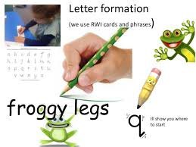
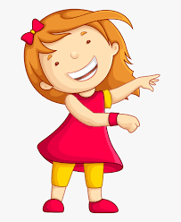Remember to have lots of fun! 

