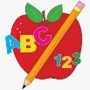Primary 2 Homework
Week Beginning: 20th October 2026
Here is a guide to help you for this week. You can choose how to organise your tasks to suit what works for you.
Please bring book bags to school every day. They will be collected in on a Friday as there will not be any homework at the weekend. If you feel you want to continue with some of the homework over the weekend, please just let me know. *Your child can use their homework jotter for any writing they do. Spelling words (these will be tested on a Friday along with the common words).
 | Literacy | Numeracy
 | Joined Phonemes  This week we are learning about aw.  Spelling words (these will be tested on a Friday along with the common words).  saw jaw draw hawk crawl awful  Your child can practise spelling their words out loud to someone then write them down. They should count how many letters they have when they spell them out loud and check that that is how many they have written.  Pick at least one word to make a sentence with.  The phonemes your child should know are –  Group 1 – ay, ea (as in leaf), ow (as in snow)  Group 2 - ue   | Addition to 20  Click the game below. Choose ‘Count on and back’ (0-20).  https://www.topmarks.co.uk/learning-to-count/blast-off  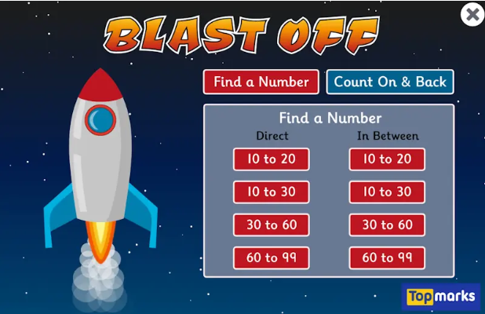
Common Words
The new common words for this week are
very took fast there

*Your child can do the same activity that they are doing for their spelling words.

Group 1 words - day away always today each ask year eat yellow grow again food

Group 2 words – blue best number other

*Continue to practise these words to make sure your child can read and spell them.
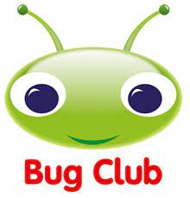

Your child will get their books home in their book bag when they have completed them in class.
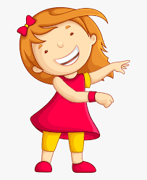Remember to have lots of fun! 