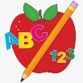Primary 2 Homework
Week Beginning: 5th October 2026
Here is a guide to help you for this week. You can choose how to organise your tasks to suit what works for you.
Please bring book bags to school every day. They will be collected in on a Friday as there will not be any homework at the weekend. If you feel you want to continue with some of the homework over the weekend, please just let me know. *Your child can use their homework jotter for any writing they do. Spelling words (these will be tested on a Friday along with the common words).
 | Literacy | Numeracy
 | Joined Phonemes  This week we are learning about ue.  Spelling words (these will be tested on a Friday along with the common words).  blue glue true clue Sue  Get your child to make up the rainbow alphabet. Use the letters with the new joined phoneme to make ue words.  Pyramid Writing – b  bl  blu  blue  Do this for each of your spelling words.  Pick at least one word to make a sentence with.  The phonemes your child should know are –  Group 1 – ay, ea (as in leaf), ow (as in snow)   | Addition to 20  Click on the game below. Click Level 2.  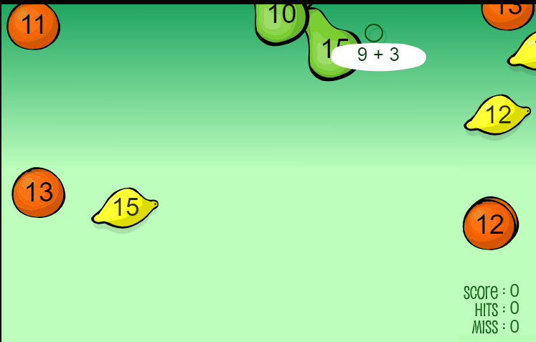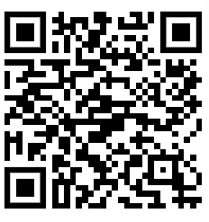  https://www.sheppardsoftware.com/math/addition/fruit-splat-game/  Use the different strategies we have been learning to work out the calculations or use your number line to help.
Common Words
The new common words for this week are
blue best number other

Cut out letters from magazines/newspapers to make these words.

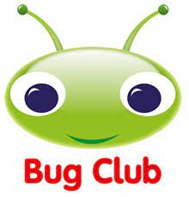

Your child will get their books home in their book bag when they have completed them in class.
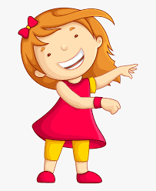Remember to have lots of fun! 