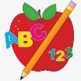Primary 2 Homework
Week Beginning: 28th September 2026
Here is a guide to help you for this week. You can choose how to organise your tasks to suit what works for you.
Please bring book bags to school every day. They will be collected in on a Friday as there will not be any homework at the weekend. If you feel you want to continue with some of the homework over the weekend, please just let me know. *Your child can use their homework jotter for any writing they do. Spelling words (these will be tested on a Friday along with the common words).
 | Literacy | Numeracy
 | Joined Phonemes  This week we are consolidating Group 1 joined phonemes – ay ea ow  Get your child to make up the rainbow alphabet and practise making, reading and writing words with these joined phonemes.  Below are the spelling lists for each joined phoneme. Can you add any more? Which list has the most?  ay - day tray play stay prayer way clay  ea - speak clean steal team stream eat wheat  ow - low grow throw follow shallow show  *Challenge: Try to pick at least one word from each spelling list to write a sentence with.   | Addition to 20  Click below. Your child can use this to work out calculations that bridge 10.  (eg. 9+4, 6+8).  This is a strategy where both of the numbers that are being added together are less than ten but add up to a teen number.  https://www.didax.com/apps/ten-frame/  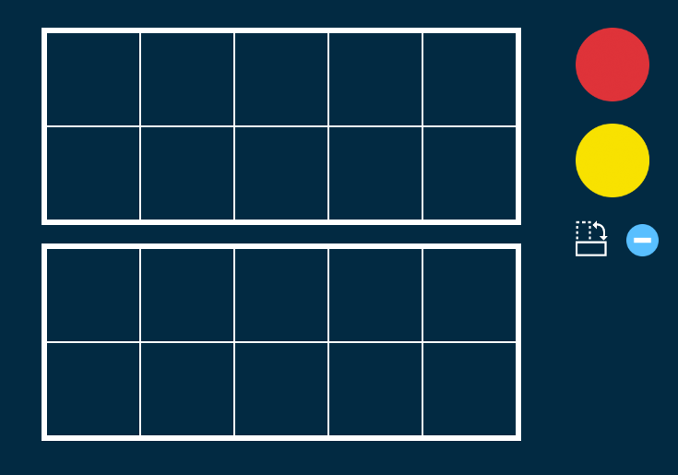    For each number in the addition calculation use a different colour counter – 9+4 (9-red,  4-yellow).  It is easier to make up the first ten frame with the counters and they can see what is left over to add to the 10 (a strategy already used).  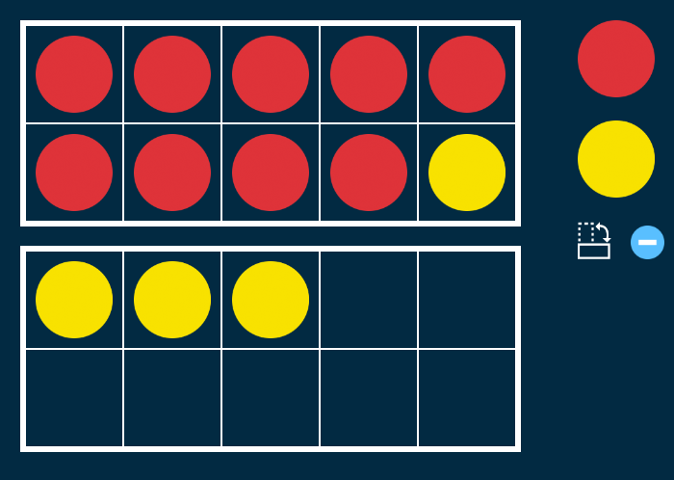  9+4 changes to 10+3 which equals 13  9+4=13  Your child can write the calculations down in their jotter.
Common Words

We are consolidating Group 1 common words –

day away always today each ask
year eat yellow grow again food

Get your child to practise writing them out in lowercase and UPPERCASE letters (eg. today TODAY).

There is a word wall in your child’s book bag to help them practise Group 1 common words. When they can read and spell the words, they can colour the brick in.

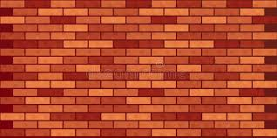
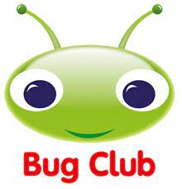

Your child will get their books home in their book bag when they have completed them in class.
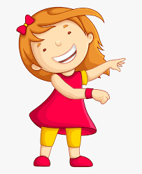Remember to have lots of fun! 

