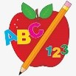 Primary 1 Homework
Week Beginning: 28th September 2026

Here is a guide to help you for this week. You can choose how to organise your tasks to suit what works for you.

Please bring book bags to school every day. They will be collected in on a Friday as there will not be any homework at the weekend. If you feel you want to continue some of the homework over the weekend, please ask for your child’s book bag.

 | Literacy | Numeracy
 | Phonics  Each week your child will get new letters in the form of milk bottle lids. Vowels are red and consonants are blue. They need to know the letter sound, name and write the letter correctly. At this stage this may be all your child can manage. Letters can be written in homework jotters using coloured pencils, pens, Mummy’s special pen (anything to encourage them to write).  Challenge  In class we have been trying to make, read and write words with the letters we have learned using magnetic letters. The children are trying very hard with this and can continue to do it at home with their milk bottle lid letters. This is called blending and can be quite tricky to begin with.  The letters that should be in their book bag are –  a t s n i p  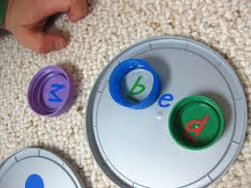  Keep scrolling down  Below is a video below for you to watch to help support your child with blending. Keep scrolling!  https://watchkin.com/ce7676932f  Common Words  Each week your child will be given 3 common words to read and spell. Some words can be sounded out but others are tricky.  There are ideas to help your child to read and spell their common words in their book bag.  Any evidence can be put in their Homework jotter eg. Photos, pictures, writing and comments.  This week’s words  a at I  Reading Books  Some children will have reading books in their book bag which they can read to family and friends. Please check book bags each night as they can only keep them for a couple of nights.   | Count forwards and backwards to 10.  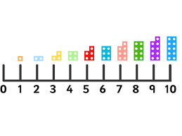  If you feel your child is confident at this encourage them to trying counting forwards and backwards to 20.  Identify numbers in your environment when walking to and from school.  
If your child is writing, please encourage them to hold their pencil correctly.

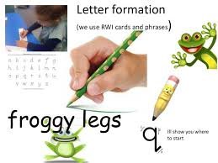
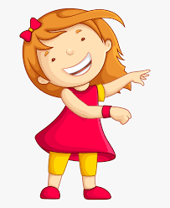Remember to have lots of fun! 